**Introduction:**

Natural disturbances, including fires, windstorms, floods, droughts, and insect outbreaks, have occurred in forests for millions of years (Lindenmayer et al. 2012). In forests of the eastern United States, wind disturbance from hurricanes, derechos (straight-line windstorms), and tornados is a dominant disturbance regime (Fischer et al. 2013). When windstorms knock down canopy trees, the increased sunlight reaching the understory and forest floor can induce environmental changes. Soil temperature extremes can increase, moisture can change depending on reduced evapotranspiration but increased summer temperature, leaf litter depth can decrease due to faster decomposition, and understory plants increase their growth rates (Greenberg and Forrest 2003, Urbanovi et al. 2014, Barber and Widick 2017). The growth of understory plants interacts with tree mortality and the creation of canopy gaps to alter microclimatic conditions (Perry et al. 2018). The fallen canopy trees cause an influx of woody debris, including both coarse and fine woody debris. Uprooted trees create tip-up mounds that alter topography of the forest floor (Perry and Herms 2019). While wind disturbance changes canopy cover and abiotic conditions, it also leaves behind many living trees, understory shrubs and herbaceous plants, seeds, root systems, soils, and surviving animals. These elements left intact after a disturbance are called biological legacies, and they influence short- and long-term changes in forest structure and function (Lindenmayer et al. 2012).

Harvesting the fallen trees after a natural disturbance is a practice called salvage-logging, and this management practice is a common response to windstorms (Lindenmayer et al. 2012). Salvage logging can help landowners recover the economic value of the fallen trees, or it may be motivated towards reducing fire risk, insect outbreak risk, or safety hazard (Perry and Herms 2019). However, there is a growing interest in managing forests in ways that conserve biodiversity, including insect populations that are threatened globally due to environmental change (Wagner 2019). This includes understanding how management practices such as salvage-logging impact insect biodiversity (Thorn et al. 2018). For example, salvage-logging alters the biological legacies left by windstorms by reducing the amount and diversity of woody debris, as well as by disturbance of understory plants, potential for soil compaction from machinery, and modified tree species composition (McNabb et al. 2001, Curtze et al. 2018, Slyder et al. 2020). The combination of natural wind disturbance followed by salvage-logging disturbance could cause longer-lasting changes to the ecosystem.

To understand how insect biodiversity is affected by forest management, an indicator taxon can be used, which is a starting point for characterizing the response of the insect community (Langor and Spence 2006). Ground beetles (Coleoptera: Carabidae) are useful indicators because they are taxonomically well known, sensitive to abiotic and biotic conditions, and sensitive to forest disturbance (Koivula 2011). Ground beetles are diverse in multiple habitats, including both mature forests and early successional habitats such as tallgrass prairies, agricultural fields, urban areas, clearcuts, and floodplains (Silverman et al. 2008, Lambeets et al. 2008, Lundgren and McCravy 2011). Within mature forests, ground beetle communities can differ based on predominate tree species, managed vs. old-growth forest, and forests with dense vs open ground vegetation (Werner and Raffa 2000, Browne et al. 2014, Perry et al. 2018). Thus, the occurrence and species composition of ground beetles can indicate fine-scale differences in habitat.

Two processes occur to the ground beetle community after a forest disturbance: influx of new species and decline of some resident species. After canopy gaps open and early successional plants begin to grow, a guild of open-habitat ground beetles typically disperses to the disturbed area. This group, including certain species of *Amara*, *Anisodactylus*, *Harpalus*, and *Chlaenius*, may immediately increase following disturbance, or may take a few years to locate the site, depending on landscape structure (Sklodowski and Garbalinska 2011, Lee et al. 2017, Barber and Widick 2017). While open-habitat species increase after disturbance, there is also a decline of forest-adapted ground beetles. For example, in Minnesota, jack pine stands that were wind-disturbed or salvaged-logged 1-3 years prior had lower numbers of *Pterostichus pensylvanicus* LeConte, *Pterostichus coracinus* (Newman), and *Sphaeroderus lecontei* Dejean than undisturbed sites (Gandhi et al. 2008). In a pine forest in Poland, forest-specialists decreased in proportional abundance over a six-year period following a tornado (Sklodowski and Garbalinska 2011). These observed decreases in forest-adapted ground beetles after windstorms and salvage-logging could be caused by a variety of factors, including environmental changes such as increased sunlight, increased summer soil temperature, and decreased leaf litter (Greenberg and Forrest 2003). Although many microclimate variables stabilize after multiple years of tree regeneration following a disturbance, other variables, such as woody debris deposition or removal, remain for decades (Gore and Patterson III 1986, Perry and Herms 2019). Studies of clearcuts in Alberta indicate that differences in beetle communities between mature and clearcut forests remain even after 27 years (Pohl et al. 2007). Thus, it is unclear how long it could take for forest-adapted ground beetles to return to areas impacted by windstorms and salvage-logging, and this subject deserves further study to inform salvage-logging practices that may increase with climate change.

While much is known about how the taxonomic composition of ground beetle communities changes after forest disturbance, less is known about how these disturbances may impact the functional diversity of beetles via changes in traits. Studies have documented that ground beetle species common in tornado-disturbed forests were smaller in size, incorporated plant material or seeds into their diets, and were capable of flight, compared to those characteristic of undisturbed forest (Sklodowski and Garbalinska 2011, Perry and Herms 2019). However, ground beetle traits can vary even among, for example, equally-sized, carnivorous, flight-incapable species. For instance, ground beetles exhibit trait syndromes (Fountain-Jones et al. 2015) associated with locomotion strategy (Forsythe 1991), including surface-walking, pushing through leaf litter, burrowing, and climbing plants (Larochelle and Larivière 2003). Ground beetle species also differ in their soil moisture preference, and this trait plays an important role in habitat selection (Thiele 1977). Because forest disturbance can affect leaf litter and vegetation cover, soil density, woody debris volume, and soil moisture, these habitat changes could disproportionately increase the fitness of ground beetle species with certain locomotion strategies and moisture preferences. Research is needed to determine if the effect of forest disturbance on ground beetles is mediated by their species-specific traits.

Our objective is to use ground beetles to study the long-term impacts of salvage-logging after a tornado. To do this, we compared the taxonomic and functional diversity of ground beetle communities among undisturbed forest (hereafter “forest”), unsalvaged windthrow (hereafter: “windthrow”), and salvage-logged windthrow (hereafter: “salvaged”) treatments, at three and ten years after a tornado. We predicted that the alpha-diversity (both taxonomic and functional) would be higher for windthrow and salvaged plots than forest control plots after only three years, due to the immigration of open-habitat species and the persistence of some forest species. After ten years, we predicted that salvaged plots would decline in alpha diversity because forest specialist species that rely on woody debris would not use salvage-logged habitat. We predicted that the species and trait composition of windthrow plots would be intermediate between those of salvaged and forest control, due to the intermediate level of disturbance created by windthrow. Finally, we predicted that salvaged plots would support many species of ground beetles with proportionally larger eyes, proportionally shorter antennae, and higher water affinity, traits which may increase fitness in a high sunlight, high soil moisture habitat.

**Methods**

Study site

Research was conducted at Powdermill Nature Preserve (PNR) in Rector, Westmoreland County, Pennsylvania (40° 9' 35.3052'' N, 79° 16' 18.3684'' W). This preserve was established as the field research station for the Carnegie Museum of Natural History in 1956 and is largely temperate deciduous forest. The annual precipitation for the years 2012-2022 was between 45 and 70 in. with a mean of 53 in. (weather station: USC00362183) (“National Centers for Environmental Information: Past Weather” 2012-2022). In June 2012, a tornado uprooted or snapped many canopy trees in two large areas of the forest, each about 120 × 480 m (Figure 1). These two areas are on north- or northwest-facing slopes, which were dominated by maple (*Acer spp*.), tuliptree (*Liriodendron tulipifera*), and black cherry (*Prunus serotina*) (Murphy et al. 2015), with an understory of predominately spicebush (*Lindera benzoin*) (Calinger et al. 2015). The tornado created patchy areas of canopy openness: the impacted areas had canopy openness values of 25% up to 90% (Slyder et al. 2020). The elevation of the impacted area ranges from around 1650 ft. to 1750 ft. A waterway, Laurel Run, is found along the west side of the impacted areas.

**Figure 1.** Map of the pitfall trap locations (need to add shapefiles of impacted areas as well as a legend).

From mid-summer through winter of 2013, half of each wind-disturbed area was salvage-logged using heavy machinery to remove both fallen and residual standing trees. In 2015, three transects were established across each area of forest impacted by the tornado (total 6 transects) (Figure 1). Transects were established across the windthrow and salvaged disturbances that extended 50 m into the surrounding undisturbed forest on each side. Along each transect, four plots were established: one plot in windthrow, one in salvaged, and two in the surrounding undisturbed forest. This resulted in a sample size of 24 plots, wherein all data collection occurred.

Ground beetle sampling and identification

Ground beetles were sampled using unbaited barrier pitfall traps in 2015 and 2022, representing three and ten years post-tornado (two and nine years post-salvage-logging). Pitfall traps preferentially collect insects that are more active and mobile, and consequently the number of ground beetles caught in pitfalls is reported as activity-abundance (Gandhi et al. 2008). Barrier pitfall traps consisted of two pairs of plastic cups (each pair having an inner 500 mL cup and an outer 1 L cup) which were placed into the ground so that the lip of the cup was flush with the ground surface. The two pairs of cups were placed 1 m from each other, and garden edging (Suncast® eco edge) was placed between them to create a barrier. Cups were filled 4 cm high with propylene glycol (recreational vehicle and marine antifreeze, Peak Company Old World Industries, Clear Lake, Texas) with a few drops of detergent. Masonite board (100 cm2) was placed at 3 cm above each cup to prevent flooding from rain. Steel hardware cloth was secured over cups using 30 cm stakes to limit mammal disturbance.

Pitfall trap sampling was conducted continuously over the growing seasons in 2015 and 2022. Trap catch was collected every two weeks, and cups were refilled with propylene glycol. In 2015, pitfall traps were installed on 27-28 May, and samples were collected on 9-10 June, 24-25 June, 8 July, 22 July, 5 August, and 17 August. In 2022, traps were installed on 1-2 June, and samples were collected on 15 June, 29 June, 13 July, 27 July, 11 August, and 23 August. Trap catch was collected by pouring the sample through a fine mesh strainer and storing the contents in a specimen cup with 70% ethanol until sorting and identification. In 2022, two additional trapping intervals were collected, on 6 September and 20 September, but these intervals were omitted from analyses so that the years 2015 and 2022 would have equivalent sampling season lengths (see Supplementary Information).

Ground beetles (Carabidae) were identified to species using taxonomic keys (Lindroth 1961, Freitag 1969, Bousquet 2010, Bousquet and Messer 2010, Hunting 2013, Harden and Guarnieri 2017). Nomenclature followed Bousquet (2012). Species vouchers were deposited at the C. A. Triplehorn Insect Collection (OSUC), Museum of Biological Diversity, The Ohio State University, Columbus, Ohio where each specimen was given a unique identifier label (Table S1).

Trait measurements

We selected eight morphological traits of beetles that have previously been shown to relate to habitat (Table 1) (Fountain-Jones, Baker, and Jordan 2015). These traits are body length, antenna length, eye protrusion, eye length, pronotum width, abdomen width, rear leg length, and rear trochanter length. Traits were measured under a dissecting microscope using an ocular micrometer to the nearest 0.1 mm. For each species, traits were measured on up to six individuals, three males and three females (Fountain-Jones, Baker, and Jordan 2015), although we did not achieve this number for rare species. The six individuals were chosen in a way that attempted to encompass the intraspecific variation in body size observed for the species. Most (185/202) specimens used for trait measurement were collected at Powdermill Nature Reserve, but a few (17/202) measured specimens were collected in Erie and Cuyahoga counties, Ohio (Table S1). These specimens were used to supplement the sample size when less than six measurable individuals were collected at Powdermill. To control for variation in beetle body size, relative measurements of all morphological traits were calculated as their ratio to body length for each individual (Ribera et al. 2001). Trait measurements were then averaged across individuals of a species to calculate species-specific means.

In addition to morphological traits, we utilized the reference Larochelle and Larivière (2003) to provide information for three additional traits: flight capability, water affinity, and forest affinity. Flight capability was coded as 1 if the species is flight-capable, 0 if the species is flight-incapable, and 0.5 if the species exhibits wing dimorphism. Water affinity was coded as 0 for xerophilous species, 1 for hygrophilous species, and 0.5 for intermediate species. Water affinity was treated as a physiological trait, because ground beetle species often have consistent humidity preferences in behavioral studies (Thiele 1977). Forest affinity was coded as “forest-specialist,” “open-habitat,” or “eurytopic” (meaning the species is found in forest clearings or in both forest and open habitats). Because only two species we found were recorded as open-habitat species in the literature, we pooled eurytopic and open-habitat species for the statistical analysis.

**Table 1**. Morphological traits and literature-based traits used in this study, and their connections to habitat variables that could be impacted by forest disturbance.

|  |  |  |
| --- | --- | --- |
| **Trait** | **Connection to habitat** | **References** |
| Body length (mm) | Shorter body length was found for ground beetles caught in wind-disturbed forests, relative to undisturbed forests. Body length is correlated with many other morphological traits. | (Barton et al. 2011, Sklodowski and Garbalinska 2011) |
| Antenna length (mm) | Tactile hunter species, which rely on sense of touch more than vision, tend to have longer antennae. Longer antenna length relative to body length was found for ground beetles caught under a tree, versus in the open. | (Bauer and Kredler 1993, Barton et al. 2011) |
| Eye protrusion (mm) | A greater eye protrusion was found in a tree-climbing ground beetle, and it may allow partial overlap in the frontal visual field. However, greater eye protrusion might prevent a ground beetle from moving through thick vegetation or soil. | (Talarico et al. 2007) |
| Eye length (mm) | Diurnal ground beetle species and/or those adapted to open environments tend to rely on vision for predator avoidance or prey detection, and thus might have longer eyes. | (Talarico et al. 2007) |
| Pronotum width (mm) | A proportionally wider pronotum can be found in robust-bodied beetles, which tend to be found within open habitats. A narrow pronotum can be an adaptation to reaching prey within hard-to-reach crevices or shells. A narrow pronotum may also be related to the beetle having an unobstructed view behind its eyes. | (Forsythe 1991, Barton et al. 2011) |
| Abdomen width (mm) | Similar pattern to pronotum width, with species having proportionally wider abdomens tending to be found in open habitats. | (Barton et al. 2011) |
| Rear leg length (mm) | Open habitats seem to favor ground beetle species with shorter legs relative to body length. Ground beetles with longer legs may be weaker at pushing through dense substrates. | (Forsythe 1991, Barton et al. 2011) |
| Rear trochanter length (mm) | The rear trochanter connects to the femur of the rear leg. Ground beetles have a bean-shaped rear trochanter that allows them to move between narrow crevices between bark, leaf litter, or soil. The muscle in the rear trochanter allows the rear leg to create a force in the dorsal direction, which expands the space and allows the beetle to move through constricted areas. The trochanter is longer, on average, in species that push themselves through soil and underneath leaf litter. It is shorter in species that walk or run above the surface of the substrate. | (Forsythe 1991, Talarico et al. 2007) |
| Flight capability (range: 0-1) | Flight-capable species (macropterous and with fully developed flight musculature) can exploit patchy, temporary habitats. Conversely, flight incapable species may have higher fitness within stable habitats. | (Ribera et al. 2001, Venn 2016) |
| Water affinity (range: 0-1) | Habitats vary in the saturation of the substrate with water, and water preference varies between ground beetle species, with some species found near riverbanks or other bodies of water, others found in moist leaf litter, and others found in dry soil. A preference for low humidity may be related to overwintering within tree stumps and logs, versus in the soil. | (Thiele 1977) |
| Forest affinity (forest specialist, eurytopic, or open-habitat) | Some ground beetle species tend to be caught in forests, underneath trees, whereas other species tend to be caught in fields, prairies, pastures, and other open habitats. | (Silverman et al. 2008) |

Forest floor environment

Environmental variables on the forest floor were quantified to assess differences among windthrow, salvaged, and undisturbed forest. Percentage canopy openness was measured using a spherical crown densiometer directly above the pitfall traps to assess light availability on the forest floor. Canopy openness was measured on 9-10 June in 2015, and on 1-2 June in 2022. Percentage cover of ground-level vegetation, leaf litter, bare ground, fine woody debris (<10 cm diameter at the large end), coarse woody debris (≥ 10 cm diameter), and rocks were estimated in two randomly selected 1 m2 quadrats around each pitfall trap. Ground cover estimates were collected on 9 June and 7 July and on 1-2 June and 13 July in 2022. Values from the two quadrats around each pitfall trap were averaged together for a site-level mean. Soil moisture was measured at three locations adjacent to each pitfall trap using a Dynamax Inc. (Houston, Texas) TH20 portable soil moisture meter with a Theta Probe ML2x sensor in 2015. Soil moisture measurements were taken biweekly when pitfall samples were collected, for a total of six dates per year. The 18 soil moisture readings at each plot were averaged together for a single mean for the year.

Statistical analysis

To determine if our sampling effort was adequate to characterize the ground beetle community, we used species accumulation curves (SACs) and Chao estimators. For each year and treatment, we created a SAC with number of sampled plots on the x-axis. This was implemented using the *specaccum* function in the R package ‘vegan’ with the ‘random’ setting, which finds the mean SAC by permuting the order of the plots (Oksanen et al. 2024, R Core Team 2024). The Chao1 estimator was used to estimate a lower bound on the true species richness of ground beetles (Chao and Chiu 2016). This estimator incorporates the number of singletons and doubletons to estimate the number of undetected species and was implemented using the function “ChaoSpecies” in the R package “SpadeR” (Chao et al. 2016).

Before calculating abundance metrics, we accounted for occasional loss of trap catch due to animal disturbance (Perry et al. 2018). Trap catches were standardized based on an 84-day trapping season (6 collection intervals * 14 days per interval). Plots where the trap catch was lost for an interval were corrected by dividing the trap catch by the number of days that the pitfall trap was operational, then multiplying by 84 days. We calculated total activity-abundance of ground beetles as the sum of the activity-abundances of all species at a plot. Furthermore, we decomposed total activity-abundance into two groups: the contribution from forest specialist species, and the contribution from species that are eurytopic or specialize in open-habitats (Larochelle and Larivière 2003). To investigate alpha-diversity at the plot level, we calculated species richness (number of species) and Shannon diversity using the package “HillR” (Li 2018). Shannon diversity was calculated using the formula exp(-Σpiln(pi)), which is the same as the Hill number of order 1. This metric takes values between 1 and the species richness, depending on the degree to which the relative abundances are equal.

We conducted a principal components analysis (PCA) using morphological traits of ground beetles to identify key axes of variation (Swenson 2014). All continuous traits had already been standardized by dividing by body length. We centered each continuous trait to a mean of 0, scaled to a variance of 1, and ran the PCA using the function “prcomp” in the R package “stats” (R Core Team 2024). We removed the species *Notiophilus aeneus* (Herbst, 1806) from the PCA analysis because inclusion of this rare species, which has unusual morphology, noticeably changed the PC axes (Table S2). After running the PCA, we added *Notiophilus* back into the analysis by centering and scaling its data using the previously-calculated scaling coefficients and then projecting the values onto the PC axes using the loading values.

We used trait data in combination with ground beetle counts to calculate functional alpha-diversity. We used the first four PC axes, which together explained 89% of the variance in the data, along with the categorical variables *Water affinity* and *Flight capability*, to calculate a Gower dissimilarity matrix between all ground beetle species in trait space using the package “FD” (Laliberte et al. 2014). The categorical variables were treated as ordinal data and the “metric” method was used to calculate dissimilarity, so that a wing dimorphic species would be counted as intermediate in its flight capability. After obtaining the dissimilarity matrix, we calculated functional alpha diversity for each plot by computing the intra-plot mean dissimilarity between pairs of species in trait space. Each calculation of dissimilarity between a pair of species was weighted by the product of the species’ relative abundances at the plot, so that more abundant species had a larger influence on functional alpha diversity (Swenson 2014). The calculation was carried out using the function *mpd* in the R package “picante” (Kembel et al. 2010).

To investigate the average traits of ground beetles at each plot, we calculated community-weighted mean (CWM) trait values. These were calculated for all functional traits as well as for the first three axes of the PCA analysis using the function “functcomp” in the R package “FD” (Laliberte et al. 2014). The first three PC axes were considered because together they explained 77% of the variation in the eight numerical traits and because they had biological meaning for locomotion and sensation.

We compared ground beetle communities among forest management treatment and years using linear mixed-effects models with the R package “lme4” (Bates et al. 2015) and “lmerTest” (Kuznetsova et al. 2017). Our response variables were total activity-abundance, activity-abundance of open-habitat and eurytopic species, activity-abundance of forest-specialist species, species richness, Shannon diversity, functional alpha diversity, and community-weighted mean (CWM) traits. In addition to treatment (windthrow, salvaged, undisturbed forest) and year (2015, 2022), we included a treatment*year interaction term in the models. Transect was included as a random effect to account for spatial structure in the data (Figure 1). For some models, the variance of the residuals differed based on the fitted value (heteroscedasticity), so we transformed these response variables using the function f(x)=ln(x) before rerunning the model. In one case, the function g(x)=ln(x+1) was used due to the presence of zeros in the response variable. In some models, a singular fit was obtained, so we removed the random effect term for transect. Because species richness is a count response variable, we used a Poisson generalized linear model (GLM) with the package “stats” (R Core Team 2024). Models were subjected to hypothesis testing using type III sums-of-squares using the package “stats” (R Core Team 2024), or the package “car” (Fox and Weisberg 2019) for the GLM. When the ANOVA showed a significant effect for treatment, pairwise comparisons between treatment groups were made using the package “emmeans” (Lenth 2024).

A similar linear mixed effects model framework was used to assess changes in environmental conditions among forest management treatments over time. Response variables were canopy openness, percentage cover of ground-level vegetation, percentage cover of leaf litter, and soil moisture. Differences in soil moisture among treatments were investigated separately for 2015 and 2022 because a different meter was used for each year.

Measures of beta-diversity were used to investigate changes in taxonomic and functional composition of ground beetle communities among forest management treatments. Taxonomic beta-diversity was calculated using Bray-Curtis dissimilarities between the ground beetle species at each plot using the package “vegan” (Oksanen et al. 2024). The species abundance matrix was first row-standardized to convert the data to relative abundances before the Bray-Curtis dissimilarity between pairs of plots was calculated. We visualized the dissimilarity matrix in two-dimensional space using nonmetric multidimensional scaling (NMDS). Next, we used a permutational multivariate analysis of variance (PERMANOVA) approach to determine if species composition varied by forest management treatment or by year, using 99,999 permutations. Furthermore, we used an analysis of multivariate homogeneity of group dispersions with the “betadisper” function to test if the treatments differed in their dispersions. Mirroring taxonomic beta-diversity, we calculated distances between plots using inter-plot mean pairwise distance in trait space with the function “comdist” in the R package “picante” (Kembel et al. 2010). Using the previously calculated Gower dissimilarity matrix, the “comdist” function calculates the expected distance in trait space between an individual beetle drawn randomly from the first plot and an individual beetle drawn randomly from the second plot. The NMDS, PERMANOVA and beta-dispersion analyses were performed in a similar manner.

**Results**

Across 2015 and 2022 between the months of June and August, a total of 1537 individuals comprising 47 species of ground beetles were collected (Table 2). Of these 47 species, 27 were caught both in 2015 and in 2022, 10 species were caught only in 2015, and 10 species were caught only in 2022. The most abundant species were *Pterostichus moestus* (15.1% of individuals collected), *Chlaenius emarginatus* (10.5%), and *Sphaeroderus stenostomus* (10.3%). Of the 47 species caught, 2 were classified in Larochelle and Larivière (2003) as open-habitat specialists, 24 were eurytopic (ie. habitat generalist), 20 were forest-specialist, and one species had unknown habitat affinity. Species accumulation curves for each treatment and year showed that species richness had begun to level out with increasing number of plots, but that our sampling effort captured 46-78% of the estimated species present (Figure S2). The Chao1 estimator for the true number of ground beetle species in 2015 was 47.1 species (95% conf. int. 39.3 - 82.2 species) while in 2022 the Chao1 estimator was 79.2 species (95% conf. int. 46.2 – 230.7 species).

Activity-abundance of ground beetles was affected by changes in the forest management treatments over time. In 2015, activity-abundance spiked in salvaged plots relative to windthrow and forest controls, but this pattern disappeared in 2022, as total activity-abundance was similar among treatments (Fig. 2A; Tables 4-5). However, what was consistent across both years was that species known to be eurytopic or open-habitat specialists were most abundant in salvaged plots (Figure 3A; F=3.601, p=0.037). Similarly, ground beetle species richness was highest in salvaged plots relative to undisturbed forest, while windthrow plots had intermediate species richness (Fig. 2B; Z=3.128, p=0.005). No patterns were detected for activity-abundance of forest specialists or Shannan diversity for either management treatment or year.

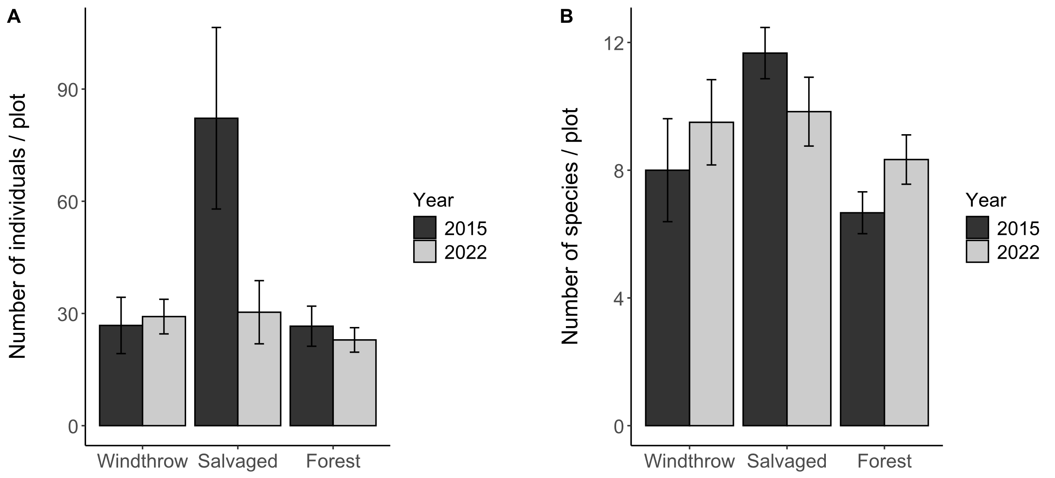**Figure 2.** Total activity-abundance (A) and species richness (B) of ground beetles collected in windthrow, salvaged, and undisturbed forest in 2015 and 2022 at Powdermill Nature Reserve Rector, Westmoreland County, Pennsylvania, USA. Bar height is the group mean, and whiskers indicate the standard error of the mean.

.

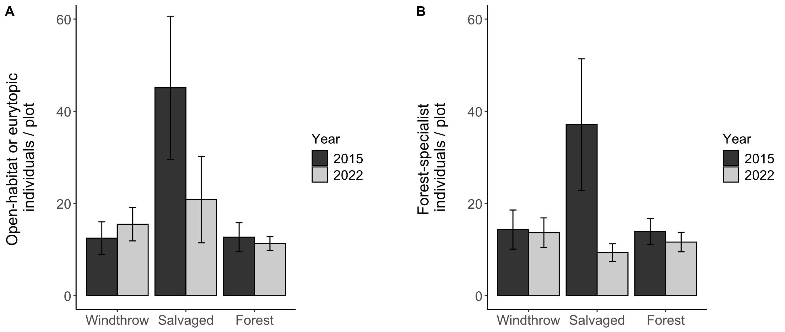

**Figure 3.** Activity-abundance of open-habitat or eurytopic ground beetle species (A) and forest-specialist species (B) collected in windthrow, salvaged, and undisturbed forest in 2015 and 2022 at Powdermill Nature Reserve Rector, Westmoreland County, Pennsylvania, USA. The forest affinity information was collected from Larochelle and Larivière (2003). Bar height is the group mean, and whiskers indicate the standard error of the mean.

**Table 2.** Total trap catch of ground beetle species (Coleoptera: Carabidae) collected via pitfall traps at Powdermill Nature Reserve, Rector, Westmoreland County, Pennsylvania, USA. Sampling occurred from 27 May to 17 August, 2015, and from 1 June to 23 August, 2022.

|  |  |  |  |  |  |
| --- | --- | --- | --- | --- | --- |
| Tribe | Species | Code | 2015 | 2022 | Total |
| Notiophilini |  |  |  |  |  |
|  | *Notiophilus aeneus* (Herbst, 1806) | No.ae | 2 | 1 | 3 |
| Cychrini |  |  |  |  |  |
|  | *Sphaeroderus canadensis* | Sp.ca | 35 | 7 | 42 |
|  | *Sphaeroderus stenostomus* | Sp.st | 76 | 82 | 158 |
|  | *Scaphinotus viduus*  (Dejean, 1826) | Sc.vi | 1 | 1 | 2 |
|  | *Scaphinotus imperfectus* (Horn, 1861) | Sc.im | 0 | 3 | 3 |
| Carabini |  |  |  |  |  |
|  | *Carabus goryi* Dejean, 1831 | Ca.go | 66 | 33 | 99 |
| Pterostichini |  |  |  |  |  |
|  | *Lophoglossus scrutator* (LeConte, 1846) | Lo.sc | 0 | 1 | 1 |
|  | *Pterostichus mutus* (Say, 1823) | Pt.mu | 1 | 0 | 1 |
|  | *Pterostichus corvinus* (Dejean, 1828) | Pt.co | 6 | 0 | 6 |
|  | *Pterostichus sayanus* Csiki, 1930 | Pt.sa | 0 | 1 | 1 |
|  | *Pterostichus coracinus* (Newman, 1838) | Pt.co | 28 | 14 | 42 |
|  | *Pterostichus melanarius* (Illiger, 1798) | Pt.me | 1 | 0 | 1 |
|  | *Pterostichus lachrymosus* (Newman, 1838) | Pt.la | 27 | 45 | 72 |
|  | *Pterostichus stygicus* (Say, 1823) | Pt.st | 62 | 70 | 132 |
|  | *Pterostichus hamiltoni* Horn, 1880 | Pt.ha | 0 | 1 | 1 |
|  | *Pterostichus moestus* (Say, 1823) | Pt.mo | 185 | 47 | 232 |
|  | *Pterostichus diligendus* (Chaudoir, 1868) | Pt.di | 1 | 1 | 2 |
|  | *Pterostichus rostratus* (Newman, 1838) | Pt.ro | 36 | 22 | 58 |
|  | *Pterostichus adoxus* (Say, 1823) | Pt.ad | 19 | 80 | 99 |
|  | *Pterostichus tristis* (Dejean, 1828) | Pt.tr | 10 | 31 | 41 |
|  | *Cyclotrachelus fucatus*  (Freitag, 1969) | Cy.fu | 5 | 1 | 6 |
|  | *Cyclotrachelus convivus* (LeConte, 1853) | Cy.co | 1 | 0 | 1 |
|  | *Cyclotrachelus sigillatus* (Say, 1823) | Cy.si | 22 | 52 | 74 |
| Chlaeniini |  |  |  |  |  |
|  | *Chlaenius emarginatus* Say, 1823 | Ch.em | 137 | 25 | 162 |
|  | *Chlaenius laticollis* Say, 1823 | Ch.la | 2 | 0 | 2 |
| Licinini |  |  |  |  |  |
|  | *Dicaelus politus* Dejean, 1826 | Di.po | 54 | 13 | 67 |
|  | *Dicaelus teter* Bonelli, 1813 | Di.te | 68 | 10 | 78 |
| Harpalini |  |  |  |  |  |
|  | *Notiobia nitidipennis* (LeConte, 1847) | No.ni | 6 | 0 | 6 |
|  | *Anisodactylus harrisii* LeConte, 1863 | An.ha | 2 | 1 | 3 |
|  | *Anisodactylus melanopus* (Haldeman, 1843) | An.me | 1 | 0 | 1 |
|  | *Anisodactylus nigerrimus* (Dejean, 1831) | An.ni | 3 | 5 | 8 |
|  | *Amphasia interstitialis* (Say, 1823) | Am.in | 6 | 0 | 6 |
|  | *Agonoleptus thoracicus* (Casey, 1914) | Ag.th | 0 | 1 | 1 |
|  | *Harpalus spadiceus* Dejean, 1829 | Ha.sp | 1 | 11 | 12 |
|  | *Trichotichnus autumnalis* (Say, 1823) | Tr.au | 10 | 2 | 12 |
| Sphodrini |  |  |  |  |  |
|  | *Pseudamara arenaria* (LeConte, 1847) | Ps.ar | 2 | 1 | 3 |
| Platynini |  |  |  |  |  |
|  | *Olisthopus parmatus*  (Say, 1823) | Ol.pa | 3 | 2 | 5 |
|  | *Agonum ferreum* Haldeman, 1843 | Ag.fe | 1 | 0 | 1 |
|  | *Agonum fidele* Casey, 1920 | Ag.fi | 31 | 3 | 34 |
|  | *Agonum retractum* LeConte, 1846 | Ag.re | 1 | 0 | 1 |
|  | *Platynus decentis* (Say, 1823) | Pl.de | 0 | 1 | 1 |
|  | *Platynus tenuicollis* (LeConte, 1846) | Pl.te | 3 | 5 | 8 |
|  | *Platynus angustatus* Dejean, 1828 | Pl.an | 19 | 17 | 36 |
| Lebiini |  |  |  |  |  |
|  | *Cymindis limbata* Dejean, 1831 | Cy.li | 0 | 1 | 1 |
|  | *Cymindis platicollis* (Say, 1823) | Cy.pl | 0 | 1 | 1 |
|  | *Apenes lucidula* (Dejean, 1831) | Ap.lu | 0 | 8 | 8 |
| Galeritini |  |  |  |  |  |
|  | *Galerita bicolor* (Drury, 1773) | Ga.bi | 0 | 3 | 3 |
| Total |  |  | 934 | 603 | 1537 |

The principal components analysis (PCA) of the eight numerical traits generated a set of axes, of which the first four axes together explained 89% of the variance. The first PC axis (39% of the variance) was associated with wider pronotum, shorter rear legs, and shorter rear trochanter (all traits listed are proportions of body length). The second axis (26% of the variance) was associated with proportionally larger eyes, but shorter body length. The third axis (13% of the variance) was associated with wider abdomen and shorter rear trochanter. The fourth axis (11% of the variance) was associated with

Species with particularly low values of PC1 included *Harpalus spadiceus* and *Anisodactylus harrisii*, while species with high values of PC1 included *Scaphinotus viduus* and *Platynus angustatus*. The second PC axis (25% of the variance) was associated with longer body length, proportionally shorter eye length, and smaller (antenna length):(rear leg length) ratio. Species with high values of PC2 included *Carabus goryi*, while species with low values included *Agonoleptus thoracicus*. The third PC axis (16% of the variance) was associated with proportionally wider abdomen and larger eye protrusion ratio (Figure S3, Tabl). The fourth PC axis (11% of the variance) was associated with

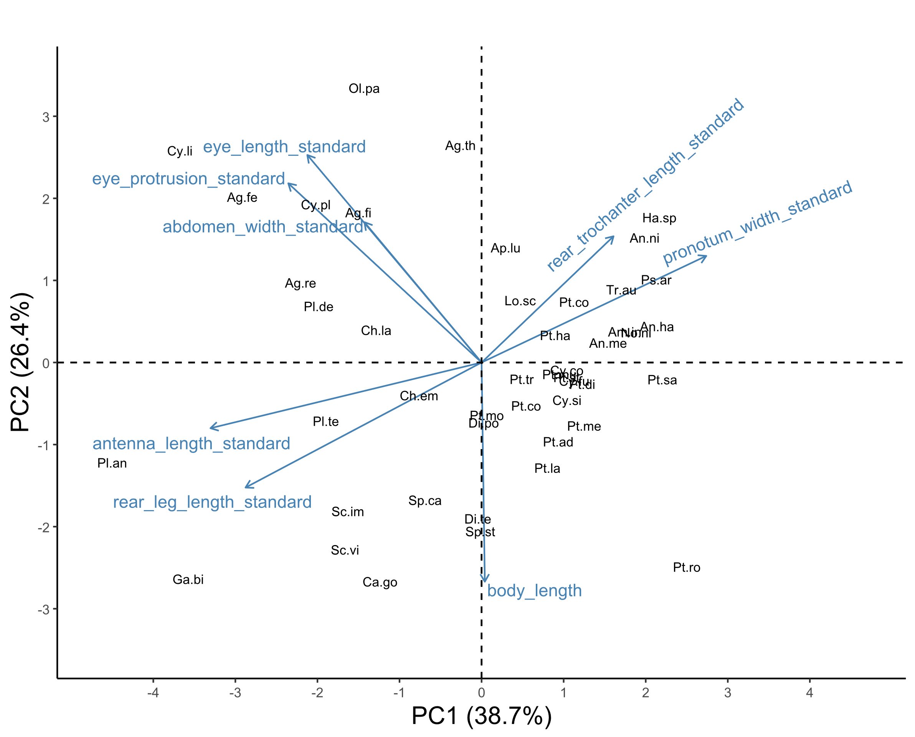

**Figure 4.** Biplot of the first two principal component axes of the principal components analysis (PCA) of the eight numerical traits measured for 47 ground beetle species. Blue arrows with labels are the eight trait variables, which are explained in Table 1. Black text in the graph indicates the locations of each species in trait space, following the abbreviations in Table 2. The word “standard” after a variable name indicates that it has previously been divided by body length to address high correlations with body length. The species *Notiophilus aeneus* was omitted from the PCA.

**Table 3.** Loading values for the first four principal components of eight numerical traits. Percentages underneath each PC column indicate the percentage of variance explained by each axis. The word “standard” after a variable name indicates that it has previously been divided by body length.

|  |  |  |  |  |
| --- | --- | --- | --- | --- |
| Trait | PC1 (39%) | PC2 (26%) | PC3 (14%) | PC4 (11%) |
| body_length | 0.01 | -0.5 | -0.3 | 0.57 |
| antenna_length_standard | -0.51 | -0.15 | -0.05 | -0.05 |
| eye_protrusion_standard | -0.37 | 0.41 | -0.17 | 0.25 |
| eye_length_standard | -0.33 | 0.48 | -0.27 | -0.21 |
| pronotum_width_standard | 0.43 | 0.24 | 0.06 | 0.4 |
| abdomen_width_standard | -0.22 | 0.32 | 0.52 | 0.58 |
| rear_leg_length_standard | -0.45 | -0.29 | -0.21 | 0.21 |
| rear_trochanter_length_standard | 0.25 | 0.29 | -0.7 | 0.17 |

Key PC axes of morphological trait variation showed differences among treatments (Tables 4-5), but functional alpha-diversity was similar among forest management treatments and across years. Salvaged plots had a high abundance of species with lower values of PC1 relative to forest controls, while windthrow plots were intermediate, as measured by the community-weighted mean (CWM) of PC1. Thus species caught in salvaged plots tended to have a trait syndrome associated with longer rear trochanters, wider pronota, and shorter legs, all proportional to body length. Investigation of individual traits suggests that rear trochanter length is the main contributor to this pattern, with species abundant in salvaged plots having proportionally longer rear trochanters (Fig. 5D). Salvaged plots also had a lower CWM of PC2 than windthrow or forest plots. Thus, salvaged plots had a high abundance of species with a trait syndrome associated with smaller body lengths and proportionally longer eyes. Supporting this pattern, we found that mean body length was lowest for beetles caught in salvaged plots, with windthrow intermediate (Fig. 5A). The eye length as a fraction of body length was greatest for beetles caught in salvaged plots (Fig. 5C). Finally, salvaged plots had a lower CWM of PC3 than forest plots, indicating beetle species with more elongated eyes (i.e., lower [eye protrusion / eye length] ratio) and wider abdomens. Eye shape was the primary driver of this pattern, rather than abdomen width (Table 4).

Two CWM traits showed significant patterns of change between years. The CWM [antenna length / rear leg length] ratio decreased from 2015 to 2022, indicating that species with long antenna relative to their rear legs were more common in 2015 than in 2022. (Fig. 5E, Table 4). Finally, the CWM flight capability of ground beetles showed a significant interaction between treatment and year. Species capable of flight were more common in salvaged plots than windthrow or undisturbed forest in 2015, but this pattern largely disappeared by 2022 (Fig. 5B, Tables 4-5).

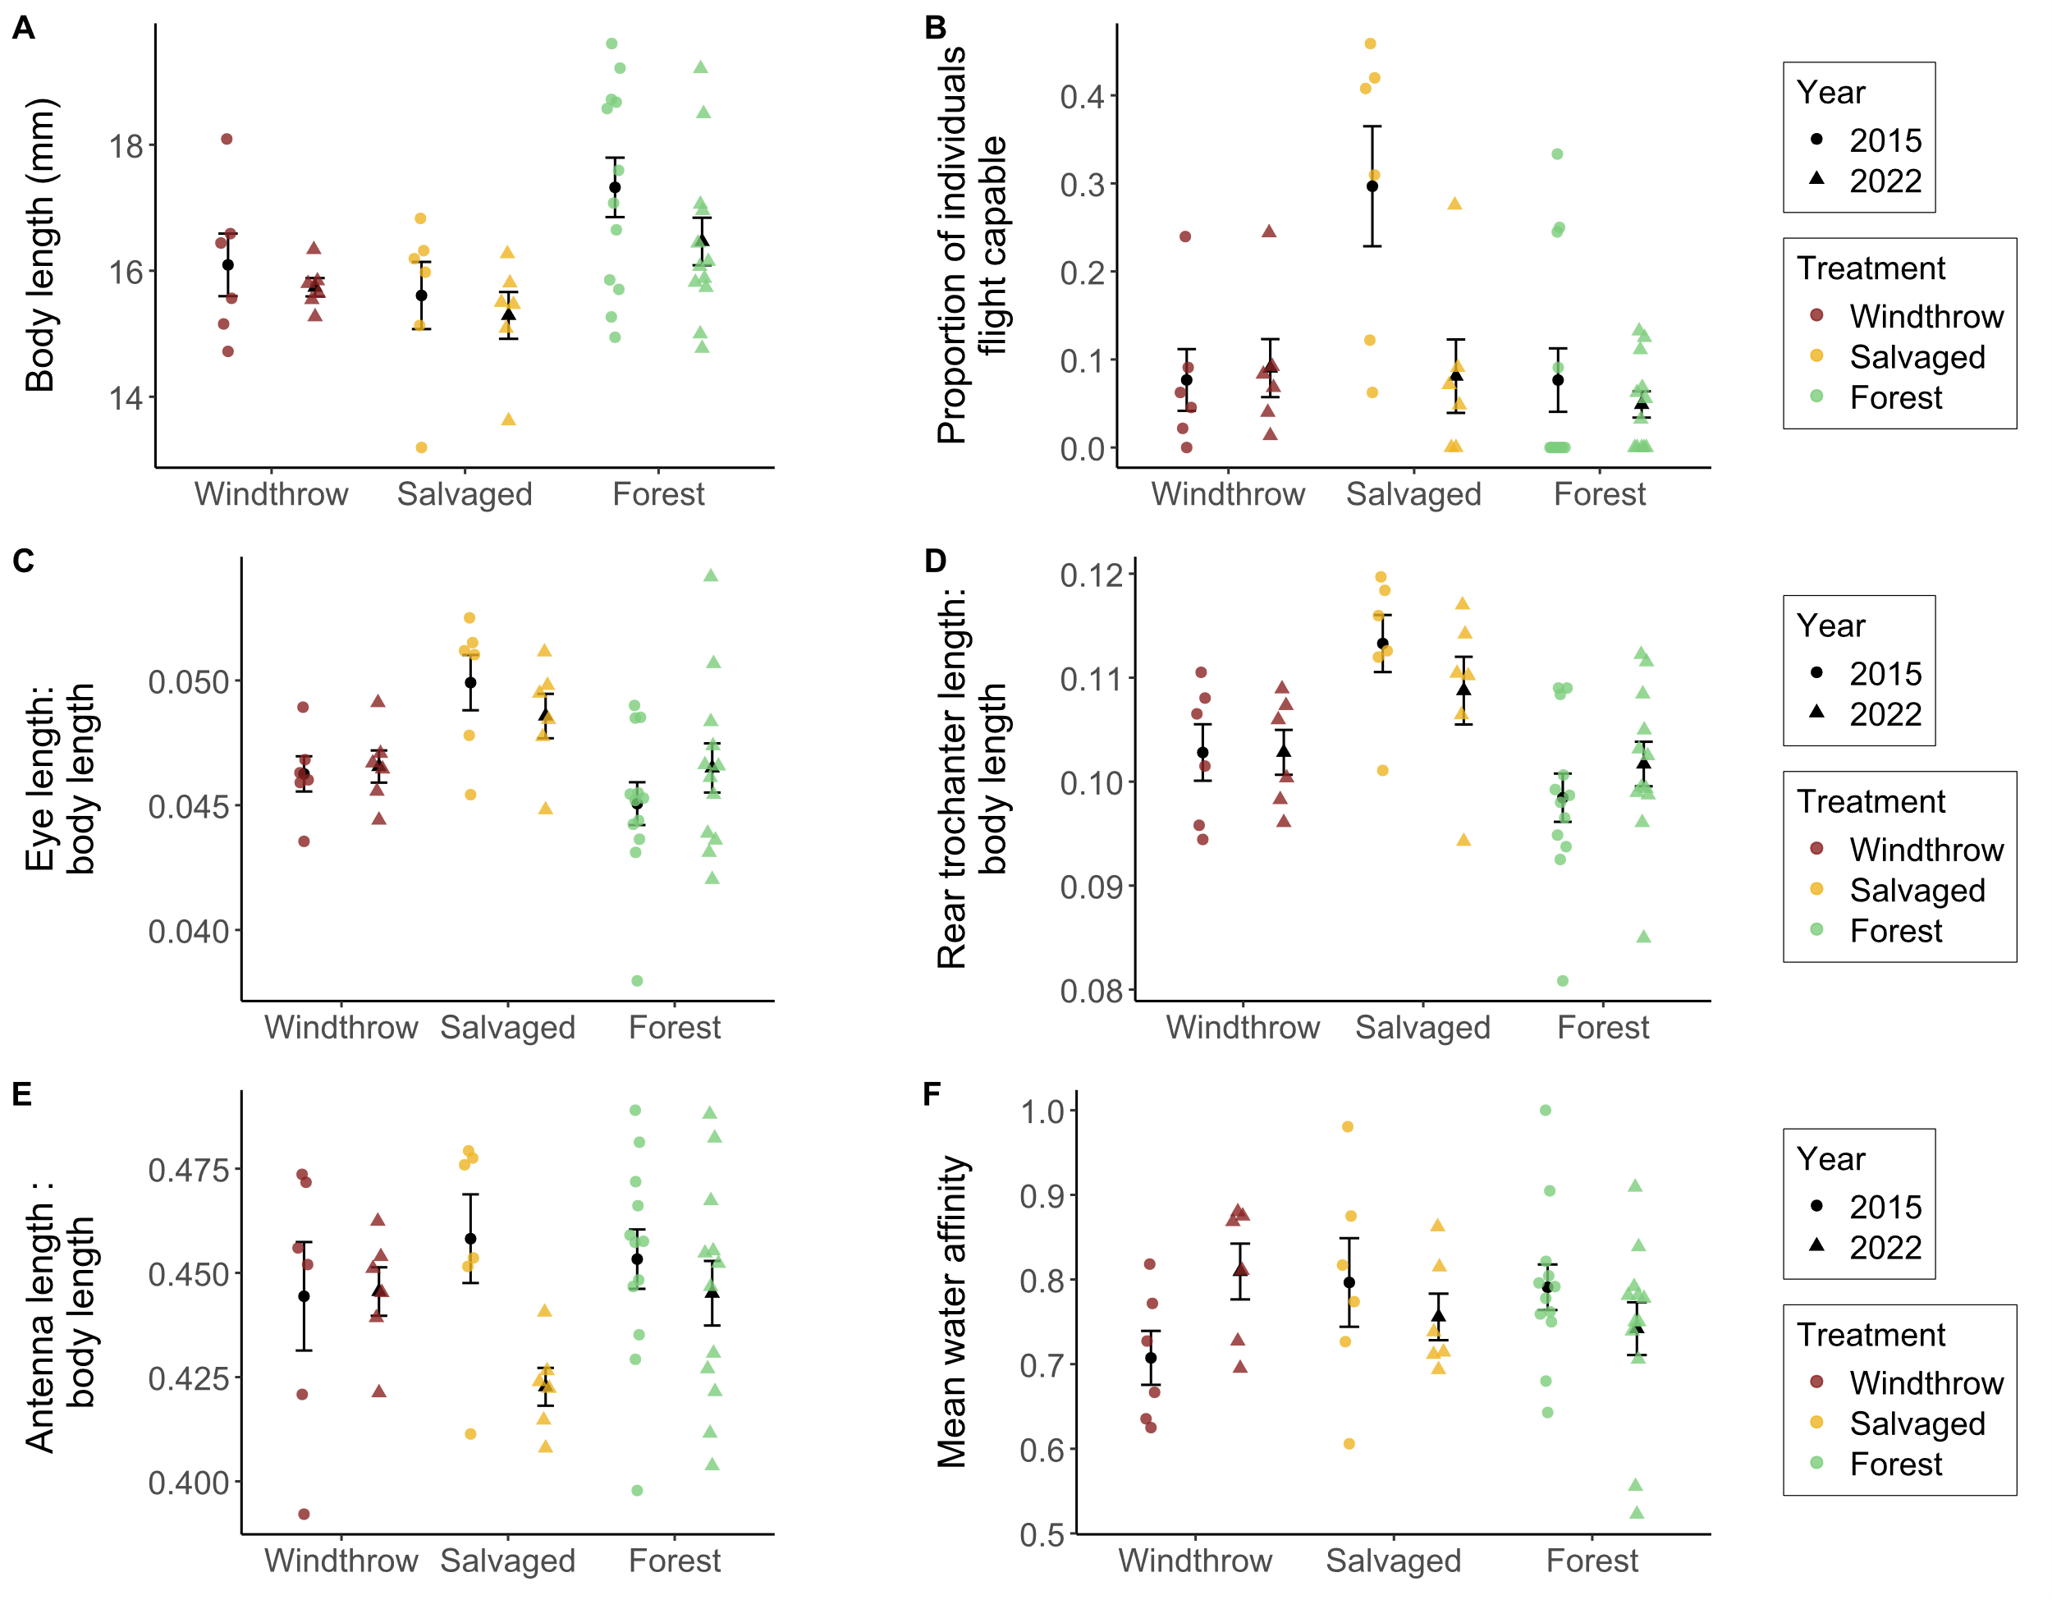

**Figure 5.** Community-weighted mean traits of ground beetles collected in windthrow, salvaged, and undisturbed forest plots in 2015 and 2022. Sample size is 6 plots for windthrow, 6 plots for salvaged, and 12 plots for undisturbed forest. (A) Body length, measured as the sum of head length, pronotum length, and elytron length. (B) Proportion of individual ground beetles caught which are flight capable, as indicated in the literature. (C) Eye length (posterior to anterior edge) standardized to body length. (D) Meta-trochanter length standardized to body length. (E) Antenna length standardized to body length. (F) Mean water affinity, as indicated by the moisture level of soils where the species has been caught in the literature.

**Table 4.** Main effects of forest management treatments (windthrow, salvaged, undisturbed forest) and year (2015, 2022) on activity-abundance, species richness, species diversity, community-weighted means (CWM) for individual traits, and functional diversity for ground beetles collected at Powdermill Nature Reserve Rector, Westmoreland County, Pennsylvania, USA. The model type column indicates if the model was a standard linear model (LM), a linear mixed-effects model with transect included as a random effect (LMM), or a generalized linear model with Poisson errors (GLM). Beetles were collected between 27 May to 17 August, 2015, and from 1 June to 23 August, 2022.

|  |  |  |  |  |  |  |  |  |
| --- | --- | --- | --- | --- | --- | --- | --- | --- |
| Response variable |  | Model  type | Treatment  (Windthrow, Salvaged, Forest) | | Year (2015, 2022) | | Treatment*Year interaction | |
|  |  |  |  | |  | |  |  |
|  |  |  | Statistic | p | Statistic | p | Statistic | p |
|  |  |  |  |  |  |  |  |  |
| Total activity-abundance |  | LMM* | **F= 5.7** | **0.007** | F=1.9 | - | **F=4.5** | **0.018** |
| Activity abundance of open-habitat and eurytopic species |  | LMM* | **F=3.6** | **0.037** | F=0.01 | - | F=2.4 | - |
| Activity abundance of forest-specialist species |  | LMM* | F=0.7 | - | F=3.4 | - | F=2.7 | - |
| Species richness |  | GLM | **X2=11.5** | **0.003** | X2=2.2 | - | X2=3.2 | - |
| Shannon diversity |  | LMM | F= 1.0 | - | F= 1.3 | - | F= 0.2 | - |
| Functional alpha-diversity |  | LM | F=0.4 | - | F= 0.001 | - | F= 1.5 | - |
| Community-weighted mean (CWM) principal component (PC) 1 |  | LMM | F=0.2 | - | F=1.5 | - | F=1.8 | - |
| CWM PC2 |  | LMM | **F=12.2** | **<0.001** | F=1.3 | - | F=0.9 | - |
| CWM PC3 |  | LMM | **F=7.3** | **0.002** | F=1.2 | - | F=1.5 | - |
| CWM Body length |  | LM | **F=5.8** | **0.006** | F=2.6 | - | F=0.3 | - |
| CWM Standardized antenna length |  | LMM | F=0.6 | - | F=3.9 | - | F=2.0 | - |
| CWM Standardized rear leg length |  | LMM | F=0.4 | - | F=1.6 | - | F=1.9 | - |
| CWM Standardized eye length |  | LMM | **F=8.1** | **0.001** | F=0.03 | - | F=1.3 | - |
| CWM Standardized eye protrusion |  | LMM | F= 1.9 | - | F= 0.3 | - | F= 0.9 | - |
| CWM Standardized pronotum width |  | LMM | F= 1.2 | - | F= 1.2 | - | F= 0.05 | - |
| CWM Standardized abdomen width |  | LMM | F= 0.4 | - | F= 0.6 | - | F= 0.6 | - |
| CWM Standardized rear trochanter length |  | LMM | **F= 11.4** | **<0.001** | F= 0.05 | - | F= 1.4 | - |
| CWM Water affinity |  | LM | F=0.1 | - | F= 0.1 | - | F= 2.7 | - |
| CWM Flight capability |  | LMM* | **F= 5.7** | **0.007** | F= 3.5 | - | **F= 3.9** | **0.028** |

*: a log transformation was done on the response variable to improve the model’s satisfaction of assumptions

**Table 5.** Means (± standard errors) of the response variables for ground beetle biodiversity.

|  |  |  |  |  |  |  |  |
| --- | --- | --- | --- | --- | --- | --- | --- |
|  |  | Unit |  | Year | Windthrow | Salvaged | Forest |
| Sample size |  | Plots |  | 2015 | n=6 | n=6 | n=12 |
|  |  |  |  | 2022 | n=6 | n=6 | n=12 |
|  |  |  |  |  |  |  |  |
| Total activity-abundance |  | Beetles per 84 trap days |  | 2015 | 26.8 ± 7.5 | 82.2 ± 24.3 | 26.6 ± 5.4 |
|  |  |  |  | 2022 | 29.2 ± 4.6 | 30.3 ± 8.4 | 22.9 ± 3.3 |
|  |  |  |  |  |  |  |  |
| Activity abundance of open-habitat species |  | Beetles per 84 trap days |  | 2015 | 0 ± 0 | 0.90 ± 0.32 | 0 ± 0 |
|  |  |  |  | 2022 | 0 ± 0 | 0.67 ± 0.67 | 0.23 ± 0.15 |
|  |  |  |  |  |  |  |  |
| Activity abundance of eurytopic species |  | Beetles per 84 trap days |  | 2015 | 12.4 ± 3.6 | 44.2 ± 15.4 | 12.7 ± 3.1 |
|  |  |  |  | 2022 | 15.5 ± 3.6 | 20.2 ± 8.7 | 11.1 ± 1.4 |
|  |  |  |  |  |  |  |  |
| Activity abundance of forest-specialist species |  | Beetles per 84 trap days |  | 2015 | 14.3 ± 4.2 | 37.1 ± 14.3 | 13.9 ± 2.8 |
|  |  |  |  | 2022 | 13.7 ± 3.2 | 9.3 ± 1.9 | 11.6 ± 2.1 |
|  |  |  |  |  |  |  |  |
| Species richness |  | Number of species |  | 2015 | 8.0 ± 1.6 | 11.7 ± 0.8 | 6.7 ± 0.7 |
|  |  |  |  | 2022 | 9.5 ± 1.3 | 9.8 ± 1.1 | 8.3 ± 0.8 |
|  |  |  |  |  |  |  |  |
| Shannon diversity |  | Effective number of species |  | 2015 | 6.5 ± 1.2 | 6.3 ± 1.0 | 5.1 ± 0.5 |
|  |  |  |  | 2022 | 7.0 ± 0.9 | 6.7 ± 1.0 | 6.4 ± 0.6 |
|  |  |  |  |  |  |  |  |
| Functional alpha-diversity |  | Within-plot mean pairwise distance in trait space |  | 2015 | 0.16 ± 0.02 | 0.18 ± 0.01 | 0.15 ± 0.01 |
|  |  |  |  | 2022 | 0.17 ± 0.01 | 0.16 ± 0.01 | 0.17 ± 0.01 |
|  |  |  |  |  |  |  |  |
| CWM PC1 |  | No unit |  | 2015 | -0.01 ± 0.17 | -0.21 ± 0.09 | 0.29 ± 0.11 |
|  |  |  |  | 2022 | 0.00 ± 0.11 | -0.45 ± 0.15 | 0.07 ± 0.12 |
|  |  |  |  |  |  |  |  |
| CWM PC2 |  | No unit |  | 2015 | 0.90 ± 0.12 | 0.49 ± 0.16 | 1.21 ± 0.12 |
|  |  |  |  | 2022 | 0.83 ± 0.06 | 0.59 ± 0.13 | 0.97 ± 0.11 |
|  |  |  |  |  |  |  |  |
| CWM PC3 |  | No unit |  | 2015 | -0.45 ± 0.14 | -0.62 ± 0.16 | -0.27 ± 0.08 |
|  |  |  |  | 2022 | -0.30 ± 0.11 | -0.55 ± 0.11 | -0.33 ± 0.09 |
|  |  |  |  |  |  |  |  |
| CWM Body length |  | mm |  | 2015 | 16.09 ± 0.50 | 15.61 ± 0.53 | 17.32 ± 0.47 |
|  |  |  |  | 2022 | 15.74 ± 0.15 | 15.29 ± 0.37 | 16.46 ± 0.38 |
|  |  |  |  |  |  |  |  |
| CWM Standardized antenna length |  | Fraction of body length |  | 2015 | 0.444 ± 0.013 | 0.458 ± 0.011 | 0.453 ± 0.007 |
|  |  |  |  | 2022 | 0.446 ± 0.006 | 0.423 ± 0.005 | 0.445 ± 0.008 |
|  |  |  |  |  |  |  |  |
| CWM Standardized rear leg length |  | Fraction of body length |  | 2015 | 0.731 ± 0.014 | 0.752 ± 0.013 | 0.744 ± 0.013 |
|  |  |  |  | 2022 | 0.740 ± 0.006 | 0.712 ± 0.008 | 0.739 ± 0.009 |
|  |  |  |  |  |  |  |  |
| CWM Antenna length : Rear leg length ratio |  | Fraction of rear leg length |  | 2015 | 0.606 ± 0.008 | 0.608 ± 0.004 | 0.607 ± 0.004 |
|  |  |  |  | 2022 | 0.6 ± 0.005 | 0.592 ± 0.003 | 0.6 ± 0.004 |
|  |  |  |  |  |  |  |  |
| CWM Standardized eye length |  | Fraction of body length |  | 2015 | 0.046 ± 0.001 | 0.05 ± 0.001 | 0.045 ± 0.001 |
|  |  |  |  | 2022 | 0.047 ± 0.001 | 0.049 ± 0.001 | 0.046 ± 0.001 |
|  |  |  |  |  |  |  |  |
| CWM Standardized eye protrusion |  | Fraction of body length |  | 2015 | 0.052 ± 0.001 | 0.054 ± 0.001 | 0.051 ± 0.001 |
|  |  |  |  | 2022 | 0.052 ± 0.000 | 0.053 ± 0.001 | 0.052 ± 0.001 |
|  |  |  |  |  |  |  |  |
| CWM eye protrusion : eye length ratio |  | Fraction of eye length |  | 2015 | 1.119 ± 0.012 | 1.096 ± 0.008 | 1.146 ± 0.007 |
|  |  |  |  | 2022 | 1.115 ± 0.007 | 1.087 ± 0.01 | 1.126 ± 0.007 |
|  |  |  |  |  |  |  |  |
| CWM Standardized pronotum width |  | Fraction of body length |  | 2015 | 0.263 ± 0.002 | 0.265 ± 0.002 | 0.262 ± 0.003 |
|  |  |  |  | 2022 | 0.265 ± 0.001 | 0.268 ± 0.002 | 0.264 ± 0.001 |
|  |  |  |  |  |  |  |  |
| CWM Standardized abdomen width |  | Fraction of body length |  | 2015 | 0.349 ± 0.006 | 0.351 ± 0.005 | 0.353 ± 0.004 |
|  |  |  |  | 2022 | 0.357 ± 0.003 | 0.349 ± 0.003 | 0.354 ± 0.003 |
|  |  |  |  |  |  |  |  |
| CWM Standardized rear trochanter length |  | Fraction of body length |  | 2015 | 0.103 ± 0.003 | 0.113 ± 0.003 | 0.098 ± 0.002 |
|  |  |  |  | 2022 | 0.103 ± 0.002 | 0.109 ± 0.003 | 0.102 ± 0.002 |
|  |  |  |  |  |  |  |  |
| CWM Water affinity |  | 0, 0.5, or 1 |  | 2015 | 0.71 ± 0.03 | 0.80 ± 0.05 | 0.79 ± 0.03 |
|  |  |  |  | 2022 | 0.81 ± 0.03 | 0.76 ± 0.03 | 0.74 ± 0.03 |
|  |  |  |  |  |  |  |  |
| CWM Flight capability |  | 0, 0.5, or 1 |  | 2015 | 0.08 ± 0.04 | 0.30 ± 0.07 | 0.08 ± 0.04 |
|  |  |  |  | 2022 | 0.09 ± 0.03 | 0.08 ± 0.04 | 0.05 ± 0.01 |

The taxonomic and functional composition of ground beetle communities differed among forest management treatments. Ground beetle communities in salvaged plots were taxonomically (Fig. 4A; F=1.745, p=0.019) distinct from undisturbed forest and functionally (Fig. 4B; F=1.789, p<0.001) distinct from windthrow and undisturbed forest. Taxonomic composition changed over time from 2015 to 2022 (F=3.803, p<0.001), but functional composition was similar across years (F=1.263, p=0.095). No significant interactions among forest management treatments and year were detected, and neither treatment groups nor years differed significantly in dispersion from their spatial medians.

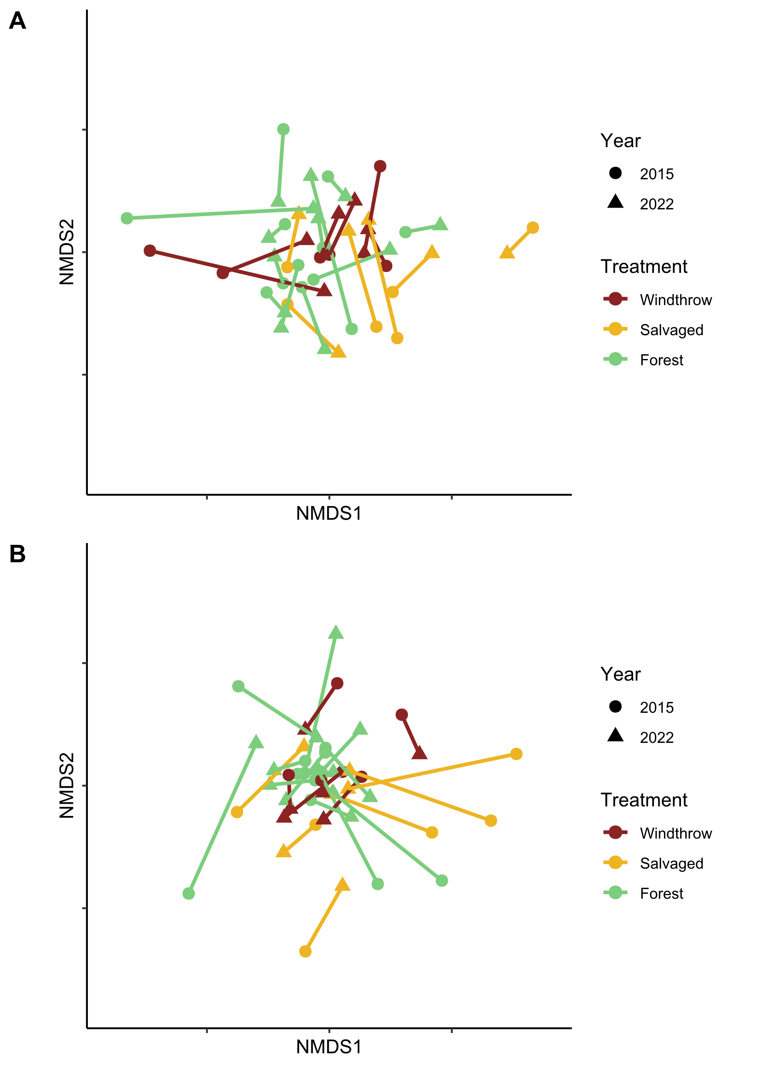

**Figure 4.** Nonmetric multidimensional scaling (NMDS) ordinations of ground beetle communities in taxonomic space (A) and functional trait space (B). Each point is a plot in a given year; shape of the point indicates the year the community was sampled, while color indicates the forest management treatment. Points corresponding to the same plot are connected with lines. The NMDS ordinations resulted in stress values of 0.224 for taxonomic beta-diversity and 0.181 for functional beta-diversity.

The forest floor environment changed among the forest management treatments over time (Tables 6-7).. Canopy openness averaged 82% above salvaged plots in 2015, much higher than windthrow or undisturbed forest plots. Although salvaged plots decreased to an average of 20% openness by 2022, this was still higher than the forest control plots. In 2015, salvaged plots had higher vegetation cover than windthrow, and windthrow had higher vegetation cover than forest controls, but these patterns largely disappeared by 2022. Meanwhile, percentage cover of leaf litter showed the opposite pattern. In 2015, salvaged plots had the lowest leaf litter cover (around 5%), followed by windthrow plots (35%) and then forest controls (61%). However, these patterns mostly disappeared by 2022. Soil moisture was similar among forest management treatments, both in 2015 and in 2022.

**Table 6.** Main effects of forest management treatments (windthrow, salvaged, undisturbed forest) and year (2015, 2022) on environmental variables in the understory at Powdermill Nature Reserve, Rector, Westmoreland County, Pennsylvania, USA. All models were linear mixed-effects models with transect included as a random effect (LMM).

|  |  |  |  |  |  |  |  |  |
| --- | --- | --- | --- | --- | --- | --- | --- | --- |
| Response variable |  | Model  type | Treatment  (Windthrow, Salvaged, Forest) | | Year (2015, 2022) | | Treatment*Year interaction | |
|  |  |  |  | |  | |  |  |
|  |  |  | Statistic | p | Statistic | p | Statistic | p |
| Vegetation percentage cover |  | LMM | **F=15.565** | **<0.001** | F=0.657 | 0.423 | **F=5.669** | **0.007** |
| Leaf litter percentage cover |  | LMM | **F=20.0451** | **<0.001** | F= 0.800 | 0.377 | **F=8.771** | **0.001** |
| Canopy openness |  | LMM* | **F=47.169** | **<0.001** | **F=45.857** | **<0.001** | **F=19.864** | **<0.001** |
| Soil moisture (2015) |  | LMM | F=0.0792 | 0.9242 | NA | NA | NA | NA |
| Soil moisture (2022) |  | LMM | F=0.2342 | 0.7939 | NA | NA | NA | NA |

*: a log transformation was done on the response variable to improve the model’s satisfaction of assumptions

**Table 7.** Means (± standard errors) of the environmental variables in the understory.

|  |  |  |  |  |  |  |  |
| --- | --- | --- | --- | --- | --- | --- | --- |
|  |  | Unit |  | Year | Forest | Salvaged | Windthrow |
| Soil moisture$ |  | 0-1.129 |  | 2015 | 0.59 ± 0.04 | 0.61 ± 0.07 | 0.60 ± 0.04 |
|  |  | 0-100% |  | 2022 | 44.82 ± 3.51 | 47.64 ± 2.54 | 48.66 ± 7.41 |
|  |  |  |  |  |  |  |  |
| Ground-level vegetation percentage cover |  | 0-100% |  | 2015 | 21.6 ± 2.8 | 73.0 ± 6.0 | 42.1 ± 10.4 |
|  |  |  |  | 2022 | 35.1 ± 4.2 | 47.7 ± 11.3 | 41.9 ± 6.7 |
|  |  |  |  |  |  |  |  |
| Leaf litter percentage cover |  | 0-100% |  | 2015 | 61.2 ± 3.6 | 5.2 ± 3.5 | 35.4 ± 7.3 |
|  |  |  |  | 2022 | 43.1 ± 4.5 | 31.5 ± 9.5 | 39.6 ± 5.8 |
|  |  |  |  |  |  |  |  |
| Canopy openness |  | 0-100% |  | 2015 | 9.1 ± 0.4 | 82.3 ± 3.4 | 13.7 ± 2.5 |
|  |  |  |  | 2022 | 7.7 ± 0.5 | 19.7 ± 10.8 | 9.1 ± 1.3 |

$: A different soil sensor was used in 2022 than was used in 2015, so readings are only comparable between treatments within a year.

**Discussion**

After a tornado knocked over canopy trees in a mature deciduous forest in southwestern Pennsylvania, land managers decided to conduct logging operations on half of the affected area. Ecologists studied the flora and fauna of the site to determine how salvage-logging impacts biodiversity and forest health. We used ground beetles (Coleoptera: Carabidae) as indicators of ecological processes occurring on the forest floor. Not only did we study the taxonomic diversity of ground beetles, but we also examined functional traits relating to sensory abilities and locomotion of these beetles, to understand how habitat alterations might differentially favor certain species. Furthermore, we sampled beetles at two points (3 years and 10 years after the tornado) to ascertain whether effects of forest management change over time. Based on previous research, we predicted that alpha-diversity (both taxonomic and functional) would increase initially in both windthrow and salvaged plots, but that over time, the alpha-diversity of salvaged plots would decline due to scarcity of woody debris. Furthermore, we predicted that windthrow plots would be intermediate between salvaged and undisturbed forest in community composition, and that species common in salvaged plots would tend to have proportionally larger eyes, proportionally shorter antennae, and higher affinity for water, due to a high sunlight, high soil moisture habitat.

Our predictions regarding alpha diversity were partially supported. In particular, the taxonomic richness of salvaged plots was higher than that of undisturbed forests, particularly in 2015. Much more dramatically than the elevated number of species was the higher activity-abundance (ie. individuals captured). In 2015, captures of a few species, including *Pterostichus stygicus*, *Chlaenius emarginatus*, and *P. moestus*, were substantially higher in salvaged plots (Fig. 2A). These three species comprised 61% (287/468) of ground beetles caught in salvaged plots in 2015, whereas this level of dominance by a three species was not observed in windthrow or forest controls. Although species richness was higher in salvaged plots, other measures of alpha-diversity, including Shannon diversity and functional alpha diversity, did not differ significantly between treatments. Thus, although salvage-logging led to an increase in number of species, it did not affect all species equally.

Delving further into the habitat preferences of the species reveals that both eurytopic species (ie. habitat generalists) and a few forest specialists benefitted from salvage-logging. For example, the eurytopic species *Chlaenius emarginatus* was moreabundant within the salvage-logged forest in 2015, at 2-years post-salvage. This species is capable of flight and is a habitat generalist. Other species of *Chlaenius* are known to oviposit within earthen cells deposited on living plant leaves or dead twigs above the ground surface, so further research could reveal specific habitat features that enabled *C. emarginatus* to thrive within salvaged locations initially after logging (King 1919). We also found some species of *Anisodactylus* in salvaged plots. These species can feed on plant seeds from ruderal plant species which increased in salvaged-logged locations due to the increased sunlight. In contrast to other studies, we did not find an influx of *Harpalus* or *Amara* species in disturbed forest plots, but this could be due to a lack of source populations in the area. While all the previously mentioned ground beetles are predominately flight-capable, there were also some flightless ground beetles that were found in high numbers in salvaged plots in 2015, including *P. stygicus*, *P. moestus*, and *Dicaelus politus*. Surprisingly, *P. moestus* and *D. politus* are described in the literature as preferring shaded ground. One possible explanation is that *P. moestus* may oviposit in rotting wood (Hamilton 1884). In salvage-logged sites in 2015, there may have been large quantities of slash left behind by logging operations, which would have been rapidly decomposing on the soil surface, and may have temporarily provided habitat for *P. moestus.* By 2022, *P. moestus* capture rates were higher in windthrow plots than salvaged plots, possibly indicating the depletion of the rotting wood resource in salvaged plots.

Examining beetle functional traits provided insights into how forest management after a tornado impacted ground beetles. Our prediction that ground beetle species common in salvaged plots would have proportionally larger eyes was supported. In fact, species with shorter body lengths and proportionally longer eyes (ie. lower values of PC axis 2) tended to be more common in salvaged plots. Vision is especially important for species that fly, whereas a reduction in eye size may occur in subterranean beetles. We not only measured eye length, but also the protrusion of the eyes as seen dorsally. As measured by the ratio of eye protrusion to eye length, we found that beetle species common in salvaged plots tended to have more elongated eyes. This could be explained by the lower captures of *Sphaeroderus stenostomus* and *Carabus goryi* which have round, protruding eyes, in salvaged plots, whereas species like *Chlaenius emarginatus* and *Pterostichus stygicus* have eyes that do not stick out as much. Species which are strong burrowers may have less-protruding eyes as an adaptation to avoid damage when excavating tunnels. Another possibility is that species that consume seeds as a food source may tend to have a wider space between the eyes to accommodate stronger crushing mandible muscles, and this could be associated with a more elongated eye shape, as was found in salvaged plots. Whereas the windthrow forest affected by the tornado had a understory with high amounts of advanced regeneration of tree saplings, salvage-logging removed that regeneration, allowing other plants to grow from the soil seedbank, such as American burnweed (*Erechtites hieraciifolius*) (Slyder et al. 2020), and some of these plants may have provided seeds as a food resource to ground beetles.

Aside from differences in eye size and shape, we found differences in the relative abundances of species with different locomotion strategies. First, the PCA identified a group of ground beetle species with low values of PC1, which have adaptations to push through dense substrates. This group consisted of many of the *Pterostichus*, *Cyclotrachelus*, and *Anisodactylus*, which tended to have proportionally shorter legs, wider pronota, and longer rear trochanters, all relative to body length. Meanwhile, other genera of ground beetles, like *Sphaeroderus*, *Carabus*, *Platynus*, and *Cymindis*, had higher values of PC1, and had adaptations to walk on the ground surface or climb on plants. We found that beetles common in salvaged plots tended to have lower values of PC1, as well as adaptations to burrowing, such as proportionally longer rear trochanters. Importantly, these trends persisted in 2022, suggesting that salvage-logging was still acting as a selective force on ground beetles after 9 years. Particularly, *P. stygicus*, a species with adaptations to burrowing, remained extremely abundant in 2022 in salvaged plots.

Other ideas (disorganized):

-Species such as *Sphaeroderus stenostomus*, *P. moestus*, *P. lachrymosus*, *P. adoxus*, and *Cyclotrachelus sigillatus* showed highest activity abundance in windthrow plots in 2022. Meanwhile, other species remained abundant in salvaged plots, but these were usually not forest specialists.

PC1 low value: This group may use a strategy called ‘wedge pushing’ to move, where they use their pronotum and head as a wedge to burrow through substrates. In contrast, species on the right side of Fig. 2 (with positive values of PC1) have

The antenna:rear leg ratio seems partly to indicate beetle size. Like the smaller beetles seem to have longer antennae relative to their rear leg. Additionally, the wedge pusher species seem to have short antennae relative to their rear legs, while the climbers (such as Cymindis, Platynus) have longer antennae relative to their rear legs.

Thus, by testing community-weighted means of PC axes, we explored trait syndromes and how a tornado disturbance and subsequent logging might favor beetle species with certain collections of traits.

However, there is an assumption that beetles caught in each treatment area spend their entire life within that treatment. In reality, beetles might move from one treatment to another over the course of a day, month, or year.

-We did find that windthrow plots were intermediate in species and trait composition between forest and salvaged plots.

-Beetles caught in salvaged plots tended to have longer trochanters. I’m curious if this varies based on the flight capability of the beetle, or if this is something independent of that trend. I’m curious what kinds of ground vegetation were in the salvaged plots (ie. what had replaced the leaf litter). I’m curious whether this observed difference in trochanters means that those long-trochanter species do more burrowing. And whether this relates to the bulk density of the soil. Or if this relates to increases in the cover of vegetation. Interestingly, some of the species that were abundant in salvaged plots in 2015 (such as *Pterostichus stygicus*) were still extremely abundant in salvaged plots in 2022. Similarly, some species rare in salvaged plots in 2015 (such as *Sphaeroderus stenostomus*) were still rare in salvaged plots in 2022. This likely caused the trend involving trochanter length to be found in both years. However, other species changed which treatment they were most abundant in,

-I’m curious about how the ability to fly may result in tradeoffs. For example, I wonder if the eyes of flight-capable ground beetles differ from those of flightless ones. Maybe flightless ground beetle species evolve eyes that face more dorsally, which would create the same pattern that we observed.

-Windthrow and salvage-logging likely changed the food web for the understory arthropods, and this topic deserves further study. I’m curious about whether ground beetles in salvaged plots eat more seeds, or if they eat different types of food, such as different rove beetles, caterpillars, or larvae. I’m curious whether the ability to switch food sources to these new prey items was a key determinant of success for ground beetles in the salvaged plots. Or if their adaptation to liquid food (external digestion) or the consumption of solid food would influence their success in disturbed habitats. Another possibility is that ants may have proliferated in salvaged plots, which may have favored beetle species that can coexist with the ants.

-The foraging/locomotion behavior of ground beetles deserves further study. It would be interesting to look at form and function. Do beetles with longer legs forage on the ground surface or in trees?

-Powdermill is in a unique part of the eastern deciduous forest called the Allegheny plateau which is in the mixed mesophytic forest, but which is near the white pine-hemlock-northern hardwoods region to the north. Because salvage-logged soils heat up more during a drought, this could favor beetles that can tolerate drier, hotter soil on the surface. Would this favor beetles that are adapted to xeric mountaintops, or perhaps southern forests? Or simply beetles with a preference for hotter temperatures?

-There are also a lot of beetle studies of logging in the boreal forests of Canada. It would be fascinating to compare these studies to studies further south, like at Powdermill. And I could compare Powdermill to beetles further south, like those studied in North Carolina.

The analysis of ground beetle traits revealed that species caught in salvaged locations tended to have certain traits which may increase their fitness in disturbed environments. Beetles caught in salvaged plots tended to have smaller bodies, tended to have larger eyes proportional to their body size, and tended to have more elongated (rather than circular) eyes. Furthermore, species caught in salvaged plots often had longer rear trochanters relative to their body size, and were more likely to be capable of flight.

In addition to patterns with individual traits, we investigated the possibility that morphological traits could be related to one another and exist as trait syndromes. We found evidence that ground beetles with proportionally longer legs also had proportionally longer antennae. Furthermore, these long-legged species also tended to have proportionally narrower pronota and proportionally shorter rear trochanters. This syndrome is likely associated with locomotion strategy: beetle species that run on the ground surface may benefit from longer legs to move faster or climb over obstacles. In contrast, beetles that move through substrates like soil or ground fissures use their short legs to generate stronger pushing forces. Short and wide hind femora have been associated with stronger horizontal pushing forces in ground beetles, as the femur houses muscles that flex and extend the tibia (Forsythe 1981). Furthermore, longer hind trochanters are associated with stronger vertical (ie. in the dorsal direction) pushing, because the hind trochanter houses the femoral rotator muscle which helps push the tarsi downwards. In fact, ground beetles may use a burrowing strategy called “oscillatory wedge pushing” where their pronotum and head act as a wedge, while their abdomen moves back and forth in order to move through a constricted area such as between layers of leaf litter, soil, underneath bark, or in rotting wood.

Although the percent cover of woody debris did not differ between the windthrow and salvaged treatments, there was higher volume of coarse woody debris in the windthrow in 2014, compared to the salvaged treatment (Perry 2016). The reduction in coarse woody debris volume in the salvaged treatment could last decades. When examining clearcut stands of varying age in New Hampshire, researchers found that the slash from clearcutting decomposed within 20-30 years, leaving low mass of downed wood for an additional 30 years, before the tree regeneration began to contribute downed wood (Gore and Patterson III 1986). Thus, salvage-logging could affect woody debris volume for >50 years.

It must be mentioned that just because a ground beetle was caught in a given forest disturbance treatment doesn’t mean that it spent the entire year at that location. Ground beetles, even flightless species, can move fairly long distances over the seasons (cite). For example, some ground beetle species forage for prey in the summer within agricultural fields but move to woodlot edges to overwinter (cite). Thus, the fact that many forest ground beetles like ____ and ____ were still caught in salvage-logged areas does not rule out that they could still need the mature forest for part of the year.

**Supplementary information**

Omission of the final two sampling intervals of 2022

In 2022, pitfall traps were sampled into September, but these final two sample intervals were omitted from the analysis. Because we only had September data in 2022, but not for 2015, we decided to omit the September 2022 data to ensure that the two years could be comparable. The species composition of ground beetles found in pitfall traps changed in September. For example, the following species were found only in September 2022, and not earlier in 2022 or in 2015: *Amerizus* sp. (Bembidiini), *Myas coracinus*, *Patrobus longicornis*, *Platynus hypolithos*, *Pterostichus atratus*, *Scaphinotus andrewsii*, *Scaphinotus ridingsii*, and *Synuchus impunctatus*. Furthermore, the abundance of some species, including *Platynus angustatus*, greatly increased in September (Figure S1). This evidence further justifies our omission of the final two sample intervals of 2022 from the statistical analysis.

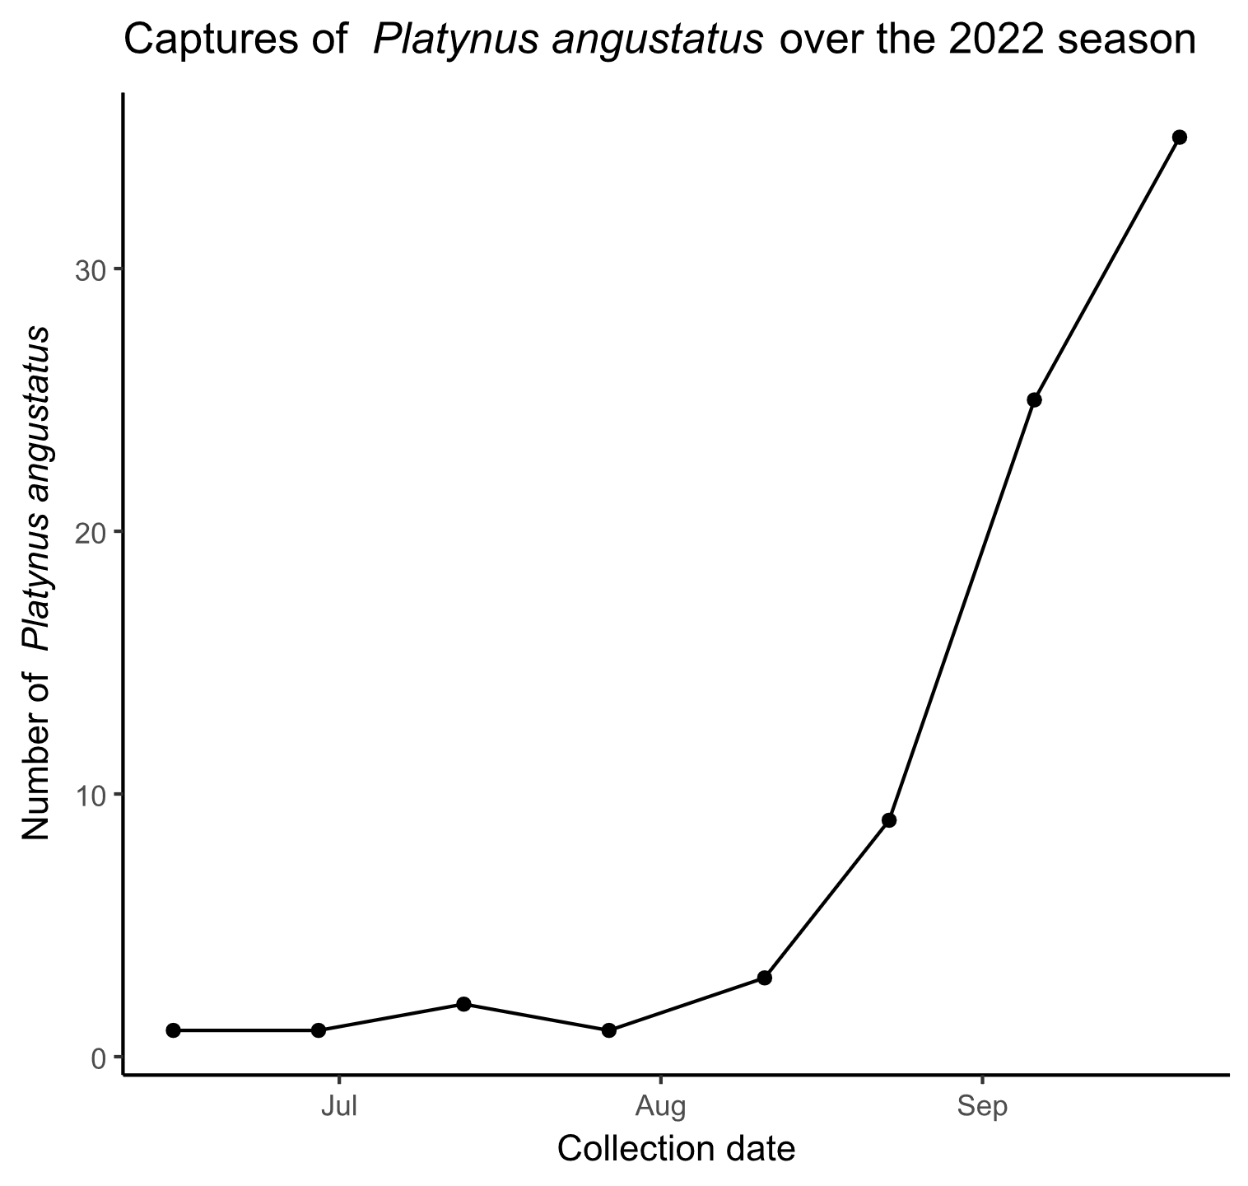

**Figure S1.** Captures of *Platynus angustatus* over the 2022 season in all pitfall traps. The x-axis shows the date of collection, while the y-axis shows number of *P. angustatus* captured during the sample interval.

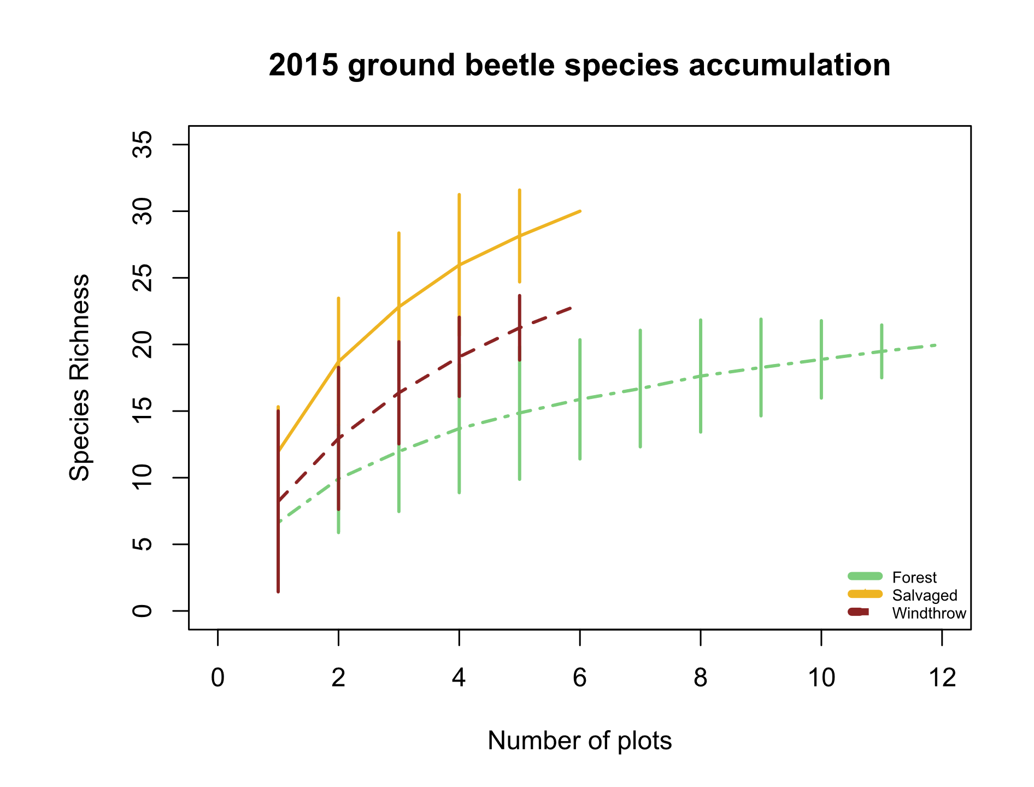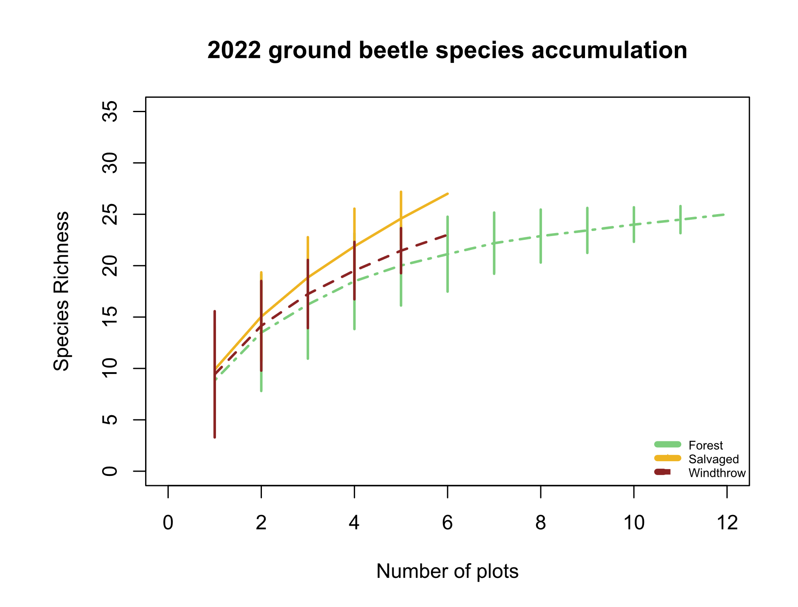

B

A

**Figure S2.** Species accumulation curves for A) 2015 ground beetles and B) 2022 ground beetles. The x-axis shows the number of sampled plots, while the y-axis shows the species richness.

**Figure S3.** Biplot of the first principal component axis against the third principal component axis of the principal components analysis (PCA) of the eight numerical traits measured for 47 ground beetle species. The species *Notiophilus aeneus* was omitted from the analysis. The additional 8 species found in September 2022 were included in the analysis but are not plotted here. Blue arrows with labels are the eight trait variables. The word “standard” after a variable name indicates that it has previously been divided by body length to address high correlations with body length.

**Table S1.** Voucher specimens used for trait measurements in this study. The Unique ID begins with “OSUC” if the specimen was already in the Ohio State University Triplehorn Insect Collection from 2015 or a previous study, whereas Unique IDs with just a number indicate 2022 specimens which will be vouchered as part of this study.

|  |  |  |  |
| --- | --- | --- | --- |
| Species | Sex | Unique ID | Location of collection |
| *Agonoleptus thoracicus* | f | 819611 | Powdermill |
| *Agonum ferreum* | m | OSUC 671705 | Powdermill |
| *Agonum ferreum* | m | OSUC 671700 | Powdermill |
| *Agonum ferreum* | f | OSUC 671704 | Powdermill |
| *Agonum ferreum* | f | OSUC 671703 | Powdermill |
| *Agonum ferreum* | f | OSUC 671702 | Powdermill |
| *Agonum fidele* | f | 819619 | Powdermill |
| *Agonum fidele* | f | 819616 | Powdermill |
| *Agonum fidele* | f | 819613 | Powdermill |
| *Agonum retractum* | m | OSUC 671697 | Powdermill |
| *Agonum retractum* | f | OSUC 523212 | Erie Co. OH |
| *Agonum retractum* | f | OSUC 523213 | Erie Co. OH |
| *Agonum retractum* | f | OSUC 523214 | Erie Co. OH |
| *Amerizus sp.* | m | 819614 | Powdermill |
| *Amphasia interstitialis* | m | Not vouchered | Powdermill |
| *Amphasia interstitialis* | f | Not vouchered | Powdermill |
| *Amphasia interstitialis* | f | Not vouchered | Powdermill |
| *Amphasia interstitialis* | f | Not vouchered | Powdermill |
| *Anisodactylus harrisii* | m | OSUC 671671 | Powdermill |
| *Anisodactylus harrisii* | m | OSUC 740908 | Cuyahoga Co. OH |
| *Anisodactylus harrisii* | m | OSUC 740906 | Cuyahoga Co. OH |
| *Anisodactylus harrisii* | f | 819778 | Powdermill |
| *Anisodactylus harrisii* | f | OSUC 740902 | Cuyahoga Co. OH |
| *Anisodactylus harrisii* | f | OSUC 740900 | Cuyahoga Co. OH |
| *Anisodactylus melanopus* | m | 819699 | Powdermill |
| *Anisodactylus nigerrimus* | m | 819634 | Powdermill |
| *Anisodactylus nigerrimus* | m | 819631 | Powdermill |
| *Anisodactylus nigerrimus* | m | 819628 | Powdermill |
| *Anisodactylus nigerrimus* | f | 819625 | Powdermill |
| *Anisodactylus nigerrimus* | f | 819622 | Powdermill |
| *Apenes lucidula* | m | 819706 | Powdermill |
| *Apenes lucidula* | m | 819715 | Powdermill |
| *Apenes lucidula* | f | 819707 | Powdermill |
| *Apenes lucidula* | f | 819716 | Powdermill |
| *Apenes lucidula* | f | 819724 | Powdermill |
| *Carabus goryi* | m | 819636 | Powdermill |
| *Carabus goryi* | m | 819639 | Powdermill |
| *Carabus goryi* | m | 819642 | Powdermill |
| *Carabus goryi* | f | 819645 | Powdermill |
| *Carabus goryi* | f | 819648 | Powdermill |
| *Carabus goryi* | f | 819651 | Powdermill |
| *Chlaenius emarginatus* | m | 819704 | Powdermill |
| *Chlaenius emarginatus* | m | 819713 | Powdermill |
| *Chlaenius emarginatus* | m | 819722 | Powdermill |
| *Chlaenius emarginatus* | f | 819705 | Powdermill |
| *Chlaenius emarginatus* | f | 819714 | Powdermill |
| *Chlaenius emarginatus* | f | 819723 | Powdermill |
| *Chlaenius laticollis* | f | OSUC 671794 | Powdermill |
| *Chlaenius laticollis* | f | OSUC 671795 | Powdermill |
| *Cyclotrachelus convivus* | m | OSUC 671699 | Powdermill |
| *Cyclotrachelus convivus* | m | OSUC 522517 | Erie Co. OH |
| *Cyclotrachelus convivus* | m | OSUC 740962 | Cuyahoga Co. OH |
| *Cyclotrachelus convivus* | f | OSUC 522528 | Erie Co. OH |
| *Cyclotrachelus convivus* | f | OSUC 522527 | Erie Co. OH |
| *Cyclotrachelus convivus* | f | OSUC 522525 | Erie Co. OH |
| *Cyclotrachelus fucatus* | m | 819782 | Powdermill |
| *Cyclotrachelus sigillatus* | m | 819753 | Powdermill |
| *Cyclotrachelus sigillatus* | m | 819763 | Powdermill |
| *Cyclotrachelus sigillatus* | m | 819773 | Powdermill |
| *Cyclotrachelus sigillatus* | f | 819754 | Powdermill |
| *Cyclotrachelus sigillatus* | f | 819764 | Powdermill |
| *Cyclotrachelus sigillatus* | f | 819774 | Powdermill |
| *Cymindis limbata* | unknown sex | 819617 | Powdermill |
| *Cymindis platicollis* | unknown sex | 819777 | Powdermill |
| *Dicaelus politus* | m | 819708 | Powdermill |
| *Dicaelus politus* | m | 819717 | Powdermill |
| *Dicaelus politus* | m | 819725 | Powdermill |
| *Dicaelus politus* | f | 819709 | Powdermill |
| *Dicaelus politus* | f | 819718 | Powdermill |
| *Dicaelus politus* | f | 819726 | Powdermill |
| *Dicaelus teter* | m | 819604 | Powdermill |
| *Dicaelus teter* | m | 819719 | Powdermill |
| *Dicaelus teter* | m | 819727 | Powdermill |
| *Dicaelus teter* | f | 819710 | Powdermill |
| *Dicaelus teter* | f | 819720 | Powdermill |
| *Dicaelus teter* | f | 819728 | Powdermill |
| *Galerita bicolor* | f | 819640 | Powdermill |
| *Galerita bicolor* | f | 819637 | Powdermill |
| *Harpalus spadiceus* | m | 819658 | Powdermill |
| *Harpalus spadiceus* | m | 819655 | Powdermill |
| *Harpalus spadiceus* | m | 819652 | Powdermill |
| *Harpalus spadiceus* | f | 819649 | Powdermill |
| *Harpalus spadiceus* | f | 819646 | Powdermill |
| *Harpalus spadiceus* | f | 819643 | Powdermill |
| *Lophoglossus scrutator* | m | 819780 | Powdermill |
| *Myas coracinus* | m | 819733 | Powdermill |
| *Myas coracinus* | f | 819734 | Powdermill |
| *Notiobia nitidipennis* | m | 672665 | Powdermill |
| *Notiobia nitidipennis* | m | 672659 | Powdermill |
| *Notiobia nitidipennis* | m | 672651 | Powdermill |
| *Notiobia nitidipennis* | f | 672663 | Powdermill |
| *Notiobia nitidipennis* | f | 672662 | Powdermill |
| *Notiobia nitidipennis* | f | 672661 | Powdermill |
| *Notiophilus aeneus* | m | 819608 | Powdermill |
| *Olisthopus parmatus* | f | 819630 | Powdermill |
| *Olisthopus parmatus* | f | 819633 | Powdermill |
| *Olisthopus parmatus* | f | OSUC 672763 | Powdermill |
| *Olisthopus parmatus* | m | OSUC 672759 | Powdermill |
| *Olisthopus parmatus* | m | OSUC 672760 | Powdermill |
| *Patrobus longicornis* | f | 819693 | Powdermill |
| *Platynus angustatus* | m | 819612 | Powdermill |
| *Platynus angustatus* | m | 819615 | Powdermill |
| *Platynus angustatus* | m | 819618 | Powdermill |
| *Platynus angustatus* | f | 819621 | Powdermill |
| *Platynus angustatus* | f | 819624 | Powdermill |
| *Platynus angustatus* | f | 819627 | Powdermill |
| *Platynus decentis* | m | 819687 | Powdermill |
| *Platynus hypolithos* | m | 819690 | Powdermill |
| *Platynus tenuicollis* | m | 819610 | Powdermill |
| *Platynus tenuicollis* | m | 819607 | Powdermill |
| *Platynus tenuicollis* | f | 819603 | Powdermill |
| *Platynus tenuicollis* | f | 819606 | Powdermill |
| *Platynus tenuicollis* | f | 819609 | Powdermill |
| *Pseudamara arenaria* | f | 819605 | Powdermill |
| *Pseudamara arenaria* | f | OSUC 671695 | Powdermill |
| *Pterostichus adoxus* | m | 819749 | Powdermill |
| *Pterostichus adoxus* | m | 819759 | Powdermill |
| *Pterostichus adoxus* | m | 819769 | Powdermill |
| *Pterostichus adoxus* | f | 819750 | Powdermill |
| *Pterostichus adoxus* | f | 819760 | Powdermill |
| *Pterostichus adoxus* | f | 819770 | Powdermill |
| *Pterostichus atratus* | m | 819735 | Powdermill |
| *Pterostichus atratus* | f | 819736 | Powdermill |
| *Pterostichus coracinus* | m | 819751 | Powdermill |
| *Pterostichus coracinus* | m | 819761 | Powdermill |
| *Pterostichus coracinus* | m | 819771 | Powdermill |
| *Pterostichus coracinus* | f | 819752 | Powdermill |
| *Pterostichus coracinus* | f | 819762 | Powdermill |
| *Pterostichus coracinus* | f | 819772 | Powdermill |
| *Pterostichus corvinus* | m | OSUC 671808 | Powdermill |
| *Pterostichus corvinus* | f | OSUC 671807 | Powdermill |
| *Pterostichus corvinus* | f | OSUC 671809 | Powdermill |
| *Pterostichus corvinus* | f | OSUC 671810 | Powdermill |
| *Pterostichus diligendus* | m | 819781 | Powdermill |
| *Pterostichus hamiltoni* | m | 819779 | Powdermill |
| *Pterostichus lachrymosus* | m | 819682 | Powdermill |
| *Pterostichus lachrymosus* | m | 819679 | Powdermill |
| *Pterostichus lachrymosus* | m | 819676 | Powdermill |
| *Pterostichus lachrymosus* | f | 819673 | Powdermill |
| *Pterostichus lachrymosus* | f | 819670 | Powdermill |
| *Pterostichus lachrymosus* | f | 819667 | Powdermill |
| *Pterostichus melanarius* | m | OSUC 522968 | Erie Co. OH |
| *Pterostichus melanarius* | m | OSUC 522969 | Erie Co. OH |
| *Pterostichus melanarius* | m | OSUC 668451 | Powdermill |
| *Pterostichus melanarius* | f | OSUC 740950 | Cuyahoga Co. OH |
| *Pterostichus moestus* | m | 819737 | Powdermill |
| *Pterostichus moestus* | m | 819741 | Powdermill |
| *Pterostichus moestus* | m | 819745 | Powdermill |
| *Pterostichus moestus* | f | 819738 | Powdermill |
| *Pterostichus moestus* | f | 819742 | Powdermill |
| *Pterostichus moestus* | f | 819746 | Powdermill |
| *Pterostichus mutus* | m | OSUC 522813 | Erie Co. OH |
| *Pterostichus mutus* | m | OSUC 671803 | Powdermill |
| *Pterostichus mutus* | m | OSUC 671804 | Powdermill |
| *Pterostichus mutus* | f | OSUC 522811 | Erie Co. OH |
| *Pterostichus mutus* | f | OSUC 671805 | Powdermill |
| *Pterostichus mutus* | f | OSUC 671801 | Powdermill |
| *Pterostichus rostratus* | m | 819729 | Powdermill |
| *Pterostichus rostratus* | m | 819739 | Powdermill |
| *Pterostichus rostratus* | m | 819743 | Powdermill |
| *Pterostichus rostratus* | f | 819730 | Powdermill |
| *Pterostichus rostratus* | f | 819740 | Powdermill |
| *Pterostichus rostratus* | f | 819744 | Powdermill |
| *Pterostichus sayanus* | m | 819731 | Powdermill |
| *Pterostichus sayanus* | f | 819732 | Powdermill |
| *Pterostichus stygicus* | m | 819755 | Powdermill |
| *Pterostichus stygicus* | m | 819765 | Powdermill |
| *Pterostichus stygicus* | m | 819775 | Powdermill |
| *Pterostichus stygicus* | f | 819756 | Powdermill |
| *Pterostichus stygicus* | f | 819766 | Powdermill |
| *Pterostichus stygicus* | f | 819776 | Powdermill |
| *Pterostichus tristis* | m | 819747 | Powdermill |
| *Pterostichus tristis* | m | 819757 | Powdermill |
| *Pterostichus tristis* | m | 819767 | Powdermill |
| *Pterostichus tristis* | f | 819748 | Powdermill |
| *Pterostichus tristis* | f | 819758 | Powdermill |
| *Pterostichus tristis* | f | 819768 | Powdermill |
| *Scaphinotus andrewsii* | m | 819660 | Powdermill |
| *Scaphinotus andrewsii* | f | 819663 | Powdermill |
| *Scaphinotus imperfectus* | m | 819672 | Powdermill |
| *Scaphinotus imperfectus* | m | 819675 | Powdermill |
| *Scaphinotus imperfectus* | m | 819678 | Powdermill |
| *Scaphinotus imperfectus* | f | 819681 | Powdermill |
| *Scaphinotus imperfectus* | f | 819684 | Powdermill |
| *Scaphinotus ridingsii* | m | 819666 | Powdermill |
| *Scaphinotus ridingsii* | m | 819669 | Powdermill |
| *Scaphinotus viduus* | m | 819654 | Powdermill |
| *Scaphinotus viduus* | m | 819657 | Powdermill |
| *Sphaeroderus canadensis* | m | 819702 | Powdermill |
| *Sphaeroderus canadensis* | m | 819711 | Powdermill |
| *Sphaeroderus canadensis* | f | 819703 | Powdermill |
| *Sphaeroderus canadensis* | f | 819712 | Powdermill |
| *Sphaeroderus canadensis* | f | 819721 | Powdermill |
| *Sphaeroderus stenostomus* | m | 819700 | Powdermill |
| *Sphaeroderus stenostomus* | m | 819697 | Powdermill |
| *Sphaeroderus stenostomus* | m | 819694 | Powdermill |
| *Sphaeroderus stenostomus* | f | 819691 | Powdermill |
| *Sphaeroderus stenostomus* | f | 819688 | Powdermill |
| *Sphaeroderus stenostomus* | f | 819685 | Powdermill |
| *Synuchus impunctatus* | f | 819696 | Powdermill |
| *Trichotichnus autumnalis* | f | 819664 | Powdermill |
| *Trichotichnus autumnalis* | f | 819661 | Powdermill |

**Table S2.** Comparison of the principal component analyses (PCA) run with and without *Notiophilus aeneus*, a species with unusual traits. Traits were listed under “Top loading values” if their loading value was ≥ 0.4. The word “standard” after each trait indicates that these values have been divided by body length prior to running the PCA.

|  |  |  |
| --- | --- | --- |
|  | **PCA with *Notiophilus aeneus*** | **PCA excluding *Notiophilus aeneus* (used in further analyses)** |
| Variance explained by PC1 | 33.1 % | 38.7 % |
| Variance explained by PC2 | 30.2 % | 26.4 % |
| Variance explained by PC3 | 14.0 % | 13.6 % |
| Top loading values for PC1 | antenna_length_standard (+0.53),  pronotum_width_standard (-0.50),  rear_leg_length_standard (+0.54) | antenna_length_standard (-0.51),  pronotum_width_standard (+0.43),  rear_leg_length_standard (-0.45) |
| Top loading values for PC2 | body_length (-0.41),  eye_protrusion_standard (+0.58),  eye_length_standard (+0.59), | body_length (-0.50),  eye_protrusion_standard (+0.41),  eye_length_standard (+0.48) |
| Top loading values for PC3 | abdomen_width_standard (-0.85) | abdomen_width_standard (+0.52)  rear_trochanter_length_standard (-0.70) |

**Table S3.** Specific definitions of the traits measured for ground beetles in this study. Literature-based traits were found using (Larochelle and Larivière 2003). Morphological traits were measured using an ocular micrometer. Sometimes multiple measurements were added to obtain a morphological trait. For example, body length was defined as elytron length + pronotum length + head length.

|  |  |  |  |
| --- | --- | --- | --- |
| **Literature-based traits** |  |  | **Definition** |
| Forest_affinity |  |  | Three options: forest specialist, open habitat, or eurytopic. Mark forest specialist if Larochelle and Lariviere (2003) only mention forested areas and/or shaded ground as a habitat. Mark open habitat if they only mention clearings, pastures, or fields, and/or if they only mention unshaded ground or open habitat. Mark eurytopic if both habitat affinities are mentioned, such as "forest clearings" or "shaded or open ground" or "roads and edges". |
| Water_affinity |  |  | Water affinity was coded as 0 for xerophilous species, 1 for hygrophilous species, and 0.5 for intermediate species. If the description mentions wet soil or proximity to waterway or lakes, then mark 1 (hygrophilous). If description mentions moist soil, then 0.5 (intermediate). If description mentions dry soil, then 0 (xerophilous). |
| Flight_capability |  |  | Flight capability was coded as 1 if the species is flight-capable, 0 if the species is flight-incapable, and 0.5 if the species exhibits wing dimorphism. Taken from Larochelle and Lariviere (2003) rather than from the specimens. |
|  |  |  |  |
| **Trait** | **Measured components** | **Unit** | **Definition** |
| Body_length |  | mm | Elytra_length + Pronotum_length + Head_length |
|  | Elytra_length | mm | Distance, along 1st elytral interval, from posterior edge of pronotum to posterior edge of elytra - not including the abdomen if it extends past elytra. The anterior 1/2 of the elytra should be horizontal. |
|  | Pronotum_length | mm | Distance, along midline, from anterior to posterior end of pronotum |
|  | Head_length | mm | Distance from tip of mandibles to anterior end of pronotum (follows Bousquet 2010). If mandibles are unequal in length, I'm taking the distance from the longer of the mandibles. I'm pitching the beetle up so that the mandibles are at roughly the same height as the frons. |
|  |  |  |  |
| Antenna_length |  | mm | Distance from the base to tip of antenna. Choose the left or right antenna depending on which is less curved and which one is not missing any segments. If necessary, divide the antenna into parts and add up the lengths. |
|  |  |  |  |
| Eye_protrusion |  | mm | Outer_eye_distance - Inner_eye_distance |
|  | Outer_eye_distance | mm | Distance between apical sides of each compound eye, EVEN if the head behind or around the eyes is slightly wider than the measured distance (example: *Pterostichus rostratus*) |
|  | Inner_eye_distance | mm | Looking down at the dorsal surface of the beetle's head, find the minimum separation between the interior edges of the compound eyes |
|  |  |  |  |
| Eye_length |  | mm | Look at beetle in profile. Turn the beetle so the rounded part of the eye is pointing straight up towards the lens of the microscope. Then measure from the anterior to posterior of the part covered in ommatidia. Measure along the direction from lateral pronotal edge to mandibles |
| Pronotum_width |  | mm | Distance between marginal sides of pronotum at their widest point |
|  |  |  |  |
| Abdomen_width |  | mm | Distance between marginal sides of elytra or abdomen at widest point. If the elytra are widely separated, then measure width of one elytron and multiply by 2. |
|  |  |  |  |
| Rear_leg_length |  | mm | Rear_femur_length + Rear_tibia_length + Rear_tarsi_length |
|  | Rear_femur_length | mm |  |
|  | Rear_tibia_length | mm | Distance from (the center of the apex of the femur) to end of tibia, not including tibial spurs |
|  | Rear_tarsi_length | mm | If necessary, measure each tarsal segment and add them up. Do not include tarsal claws. |
|  |  |  |  |
| Rear_trochanter_length |  | mm | Length of the bean-shaped rear trochanter |

**References**

Barber, N. A., and W. L. Widick. 2017. Localized Effects of Tornado Damage on Ground Beetle Communities and Vegetation in a Forested Preserve. Natural Areas Journal 37:489–496.

Barton, P. S., H. Gibb, A. D. Manning, D. B. Lindenmayer, and S. A. Cunningham. 2011. Morphological traits as predictors of diet and microhabitat use in a diverse beetle assemblage: MORPHOLOGICAL TRAITS OF BEETLES. Biological Journal of the Linnean Society 102:301–310.

Bates, D., M. Mächler, B. Bolker, and S. Walker. 2015. Fitting Linear Mixed-Effects Models Using **lme4**. Journal of Statistical Software 67.

Bauer, T., and M. Kredler. 1993. Morphology of the compound eyes as an indicator of life-style in carabid beetles. Canadian Journal of Zoology 71:799–810.

Bousquet, Y. 2010. Illustrated identification guide to adults and larvae of northeastern North American ground beetles: Coleoptera : Carabidae. Pensoft, Sofia.

Bousquet, Y. 2012. Catalogue of Geadephaga (Coleoptera: Adephaga) of America, north of Mexico. ZooKeys 245:1–1722.

Bousquet, Y., and P. Messer. 2010. Redescription of Stenolophus thoracicus Casey (Coleoptera, Carabidae, Harpalini), a valid species. ZooKeys 53:25–31.

Browne, R., S. Maveety, L. Cooper, and K. Riley. 2014. Ground Beetle (Coleoptera: Carabidae) Species Composition in the Southern Appalachian Mountains. Southeastern Naturalist 13:407–422.

Calinger, K., E. Calhoon, H. Chang, J. Whitacre, J. Wenzel, L. Comita, and S. Queenborough. 2015. Historic Mining and Agriculture as Indicators of Occurrence and Abundance of Widespread Invasive Plant Species. PLOS ONE 10:e0128161.

Chao, A., and C. Chiu. 2016. Species Richness: Estimation and Comparison. Pages 1–26 *in* R. S. Kenett, N. T. Longford, W. W. Piegorsch, and F. Ruggeri, editors. Wiley StatsRef: Statistics Reference Online. First edition. Wiley.

Chao, A., K. H. Ma, T. C. Hsieh, and C. Chiu. 2016. SpadeR: Species-Richness Prediction and Diversity Estimation with R.

Curtze, A. C., T. A. Carlo, and J. W. Wenzel. 2018. The Effects of a Tornado Disturbance and a Salvaged Timber Extraction on the Seed-Rain and Recruitment Community of an Eastern Temperate Deciduous Forest. Northeastern Naturalist 25:627.

Fischer, A., P. Marshall, and A. Camp. 2013. Disturbances in deciduous temperate forest ecosystems of the northern hemisphere: their effects on both recent and future forest development. Biodiversity and Conservation 22:1863–1893.

Forsythe, T. G. 1981. Running and Pushing in Relationship to Hind Leg Structure in Some Carabidae (Coleoptera). The Coleopterists Bulletin 35:353–378.

Forsythe, T. G. 1991. Feeding and locomotory functions in relation to body form in five species of ground beetle (Coleoptera: Carabidae). Journal of Zoology 223:233–263.

Fountain-Jones, N. M., S. C. Baker, and G. J. Jordan. 2015. Moving beyond the guild concept: developing a practical functional trait framework for terrestrial beetles. Ecological Entomology 40:1–13.

Fox, J., and S. Weisberg. 2019. An {R} Companion to Applied Regression. Sage, Thousand Oaks {CA}.

Freitag, R. 1969. A revision of the species of the genus Evarthrus LeConte (Coleoptera: Carabidae). Quaestiones Entomologicae 5:88–212.

Gandhi, K. J. K., D. W. Gilmore, S. A. Katovich, W. J. Mattson, J. C. Zasada, and S. J. Seybold. 2008. Catastrophic windstorm and fuel-reduction treatments alter ground beetle (Coleoptera: Carabidae) assemblages in a North American sub-boreal forest. Forest Ecology and Management 256:1104–1123.

Gore, J. A., and W. A. Patterson III. 1986. Mass of downed wood in northern hardwood forests in New Hampshire: potential effects of forest management. Canadian Journal of Forest Research 16:335–339.

Greenberg, C. H., and T. G. Forrest. 2003. SEASONAL ABUNDANCE OF GROUND-OCCURRING MACROARTHROPODS IN FOREST AND CANOPY GAPS IN THE SOUTHERN APPALACHIANS. Southeastern Naturalist 2:591–608.

Hamilton, J. 1884. THE SURVIVAL OF THE FITTEST AMONG CERTAIN SPECIES OF PTEROSTICHUS AS DEDUCED FROM THEIR HABITS. The Canadian Entomologist 16:73–77.

Harden, C. W., and F. G. Guarnieri. 2017. Illustrated Key and Photo Atlas of the Snail-eating Ground Beetles in the Genus Scaphinotus Dejean (Coleoptera: Carabidae: Cychrini) Occurring in the Mid-Atlantic Region. The Maryland Entomologist 7:16–34.

Hunting, W. 2013. A taxonomic revision of the Cymindis (Pinacodera) limbata species group (Coleoptera, Carabidae, Lebiini), including description of a new species from Florida, U.S.A. ZooKeys 259:1–73.

Kembel, S. W., P. D. Cowan, M. R. Helmus, W. K. Cornwell, H. Morlon, D. D. Ackerly, S. P. Blomberg, and C. O. Webb. 2010. Picante: R tools for integrating phylogenies and ecology. Bioinformatics 26:1463–1464.

King, J. L. 1919. Notes on the Biology of the Carabid Genera Brachynus, Galerita and Chlaenius*. Annals of the Entomological Society of America 12:382–388.

Koivula, M. 2011. Useful model organisms, indicators, or both? Ground beetles (Coleoptera, Carabidae) reflecting environmental conditions. ZooKeys 100:287–317.

Kuznetsova, A., P. B. Brockhoff, and R. H. B. Christensen. 2017. **lmerTest** Package: Tests in Linear Mixed Effects Models. Journal of Statistical Software 82.

Laliberte, E., P. Legendre, and B. Shipley. 2014. FD: measuring functional diversity from multiple traits, and other tools for functional ecology. R.

Lambeets, K., M. L. Vandegehuchte, J. Maelfait, and D. Bonte. 2008. Understanding the impact of flooding on trait‐displacements and shifts in assemblage structure of predatory arthropods on river banks. Journal of Animal Ecology 77:1162–1174.

Langor, D. W., and J. R. Spence. 2006. Arthropods as ecological indicators of sustainability in Canadian forests. The Forestry Chronicle 82:344–350.

Larochelle, A., and M.-C. Larivière. 2003. A natural history of the ground-beetles (Coleoptera: Carabidae) of America north of Mexico. Pensoft Publ, Sofia.

Lee, C. M., T.-S. Kwon, and K. Cheon. 2017. Response of ground beetles (Coleoptera: Carabidae) to forest gaps formed by a typhoon in a red pine forest at Gwangneung Forest, Republic of Korea. Journal of Forestry Research 28:173–181.

Lenth, R. V. 2024. emmeans: Estimated Marginal Means, aka Least-Squares Means. R.

Li, D. 2018. hillR: taxonomic, functional, and phylogenetic diversity and similarity through Hill Numbers. Journal of Open Source Software 3:1041.

Lindenmayer, D., P. J. Burton, and J. F. Franklin. 2012. Salvage logging and its ecological consequences. Island Press, United States.

Lindroth, C. H. 1961. The Ground-beetles of Canada and Alaska.

Lundgren, J., and K. McCravy. 2011. Carabid beetles (Coleoptera: Carabidae) of the Midwestern United States: a review and synthesis of recent research. Terrestrial Arthropod Reviews 4:63–94.

McNabb, D. H., A. D. Startsev, and H. Nguyen. 2001. Soil Wetness and Traffic Level Effects on Bulk Density and Air‐Filled Porosity of Compacted Boreal Forest Soils. Soil Science Society of America Journal 65:1238–1247.

Murphy, S. J., L. D. Audino, J. Whitacre, J. L. Eck, J. W. Wenzel, S. A. Queenborough, and L. S. Comita. 2015. Species associations structured by environment and land‐use history promote beta‐diversity in a temperate forest. Ecology 96:705–715.

National Centers for Environmental Information: Past Weather. 2012, 2022. . National Oceanic and Atmospheric Administration.

Oksanen, J., G. Simpson, F. Blanchet, Kindt R, Legendre P, Minchin P, O’Hara R, Solymos P, Stevens M, Szoecs E, Wagner H, Barbour M, Bedward M, Bolker B, Borcard D, Carvalho G, Chirico M, De Caceres, M, Durand S, Evangelista H, FitzJohn R, Friendly M, Furneaux B, Hannigan G, Hill M, Lahti L, McGlinn D, Ouellette M, Ribeiro, and Cunha E, Smith T, Stier A, Ter Braak C, Weedon J. 2024. _vegan: Community Ecology Package_. R.

Perry, K., and D. Herms. 2019. Dynamic Responses of Ground-Dwelling Invertebrate Communities to Disturbance in Forest Ecosystems. Insects 10:61.

Perry, K. I. 2016. Presented in Partial Fulfillment of the Requirements for the Degree Doctor of Philosophy in the Graduate School of The Ohio State University. PhD, Ohio State University, Columbus, OH.

Perry, K. I., K. F. Wallin, J. W. Wenzel, and D. A. Herms. 2018. Forest disturbance and arthropods: Small‐scale canopy gaps drive invertebrate community structure and composition. Ecosphere 9:e02463.

Pohl, G. R., D. W. Langor, and J. R. Spence. 2007. Rove beetles and ground beetles (Coleoptera: Staphylinidae, Carabidae) as indicators of harvest and regeneration practices in western Canadian foothills forests. Biological Conservation 137:294–307.

R Core Team. 2024. R: A Language and Environment for Statistical Computing. R Foundation for Statistical Computing, Vienna, Austria.

Ribera, I., S. Dolédec, I. S. Downie, and G. N. Foster. 2001. EFFECT OF LAND DISTURBANCE AND STRESS ON SPECIES TRAITS OF GROUND BEETLE ASSEMBLAGES. Ecology 82:1112–1129.

Silverman, B., D. J. Horn, F. F. Purrington, and K. J. K. Gandhi. 2008. Oil Pipeline Corridor Through an Intact Forest Alters Ground Beetle (Coleoptera: Carabidae) Assemblages in Southeastern Ohio. Environmental Entomology 37:725–733.

Sklodowski, J., and P. Garbalinska. 2011. Ground beetle (Coleoptera, Carabidae) assemblages inhabiting Scots pine stands of Puszcza Piska Forest: six-year responses to a tornado impact. ZooKeys 100:371–392.

Slyder, J. B., J. W. Wenzel, A. A. Royo, M. E. Spicer, and W. P. Carson. 2020. Post-windthrow salvage logging increases seedling and understory diversity with little impact on composition immediately after logging. New Forests 51:409–420.

Swenson, N. G. 2014. Functional and Phylogenetic Ecology in R. Springer New York, New York, NY.

Talarico, F., M. Romeo, A. Massolo, P. Brandmayr, and T. Zetto. 2007. Morphometry and eye morphology in three species of Carabus (Coleoptera: Carabidae) in relation to habitat demands. Journal of Zoological Systematics and Evolutionary Research 45:33–38.

Thiele, H.-U. 1977. Carabid Beetles in Their Environments. Springer, Berlin, Heidelberg.

Thorn, S., C. Bässler, R. Brandl, P. J. Burton, R. Cahall, J. L. Campbell, J. Castro, C.-Y. Choi, T. Cobb, D. C. Donato, E. Durska, J. B. Fontaine, S. Gauthier, C. Hebert, T. Hothorn, R. L. Hutto, E.-J. Lee, A. B. Leverkus, D. B. Lindenmayer, M. K. Obrist, J. Rost, S. Seibold, R. Seidl, D. Thom, K. Waldron, B. Wermelinger, M.-B. Winter, M. Zmihorski, and J. Müller. 2018. Impacts of salvage logging on biodiversity: A meta-analysis. Journal of Applied Ecology 55:279–289.

Urbanovi, V., D. Miklisová, and A. Mock. 2014. Activity of epigeic arthropods in differently managed windthrown forest stands in the High Tatra Mts. North-western Journal of Zoology 10:337–345.

Venn, S. 2016. To fly or not to fly: Factors influencing the flight capacity of carabid beetles (Coleoptera: Carabidae). European Journal of Entomology 113:587–600.

Wagner, D. L. 2019. Insect Declines in the Anthropocene.

Wei, T., and V. Simko. 2024. R package “corrplot”: Visualization of a Correlation Matrix.

Werner, S. M., and K. F. Raffa. 2000. Effects of forest management practices on the diversity of ground-occurring beetles in mixed northern hardwood forests of the Great Lakes Region. Forest Ecology and Management.